Patient Safety Incident Response Plan

Effective date: 01 March 2024
Estimated refresh date: 31 March 2025

Final Version 0.1
 | NAME | TITLE | DATE
Author | Denise Hylton-Mcintosh | Head of Patient Safety | 18 June 2023
Reviewer | Quality Committee  Integrated Care Board (ICB) | Members include Chief Nursing Officer, Deputy Chief Nursing Officer, Chief Medical Officer, Non-Executive Director, Patient Safety Partners  PSIRF Lead | 20 July 2023  18 August 2023  12 December 2023
Final Authoriser | Quality Committee  ICB |  | 25 August 2023  28 January 2024

CONTENTS
 |  | PAGE
1.0 | Purpose, scope, aims and objectives | 3
2.0 | Resource analysis | 4
3.0 | Our patient safety incident response plan: national requirements | 7
4.0 | Recommendations and learning | 9
5.0 | Roles and responsibilities | 10
6.0 | Patient Safety Incident reporting arrangements | 12
7.0 | Support patients, families and carers affected by PSIs | 12
8.0 | Support for staff affected by PSIs | 13
9.0 | Monitoring outcomes of PSIIs and Learning Response | 14
10.0 | Document tracking | 14
Appendix 1 | PSIRF Learning Response and Techniques | 15
Appendix 2 | Four step incident management process | 16-17
Appendix 3 | Joint System Investigation process | 18
Appendix 4 | Patient Engagement checklist | 18

Introduction
The Patient safety incident response framework (PSIRF) provides a new approach to how we respond to incidents removing barriers and promote ways to successfully learn and make improvements following an incident. Those who are leading the patient safety agenda within Kent Community Health Foundation Trust (KCHFT) will help to decide how we respond to patient safety incidents based on the need to generate insight to inform safety improvement where it matters most. One of the requirements within PSIRF is that we have a Patient Safety Incident Response Plan (PSIRP). This PSIRP document covers responses conducted solely for the purpose of systems-based learning and improvement.
- Purpose, scope, aims and objectives

  - Purpose

This patient safety incident response plan sets out how KCHFT intends to respond to patient safety incidents reported by staff, patients, relatives or carers. The plan is not a permanent rule that cannot be changed therefore, this plan will be reviewed at least annually with ICB but can be more often as this is a ‘live, evolving’ document. During this time, we will remain flexible and consider the specific circumstances in which patient safety issues and incidents occurred and the needs of those affected.

  - Scope

There are many ways to respond to an incident. This document covers responses conducted solely for the purpose of system learning and improvement.
Patient safety incidents are any unintended or unexpected incident which could have, or did, lead to harm for one or more patients receiving healthcare.
There is no remit to apportion blame or determine liability, preventability or cause of death in a response conducted for the purpose of learning and improvement.

Learning Responses covered in this Plan include (see Appendix 1 for details):
- Patient Safety Incident Investigations (PSIIs)
- After- Action Reviews (AAR)
- Hot debrief/ Swarm huddle
- Cluster review
- Thematic reviews
- Structured Judgement reviews

There may be other types of response to support with specific issues or concerns. Examples of such responses include complaints management, claims handling, human resources investigations into employment concerns, professional standards investigations, coroners’ inquests or criminal investigations. The principle aims of each of these responses differ from the aims of a patient safety response and are outside the scope of this Plan.

  - Aims and objectives

The four strategic aims of the PSIRF are aligned with our own Trust vision statements.
PSIRF aims:
- Compassionate engagement and involvement of those affected by patient safety incidents
- Application of a range of system-based approaches to learning from patient safety incidents
- Considered and proportionate responses to patient safety incidents
- Supportive oversight focused on strengthening response system functioning and improvement

KCHFT care values
- Compassionate – We put patients and our service users at the heart of everything we do. We're positive, kind and polite. We understand diversity. We're respectful, patient and tolerant.
- Aspirational – We feel empowered and we empower our patients. We strive to improve. Our focus is on research and generating ideas and innovations. We're open, transparent and we think creatively.
- Responsive – We listen. We act. We communicate clearly. We do what we say we will. We take account of other's opinions.
- Excellent – We strive to deliver the best care we can. We grow a culture of excellence in our teams. We challenge complacency.

- Resource Analysis

2.1 Background
PSIRF offers many ways to respond to an incident providing organisation with options to learn and improve from patient safety incident.

KCHFT incident management process supports techniques to identify areas of improvement, responding to concerns raised by patient, family or carer and implementing immediate safety actions.

A Patient Safety Incident Review (PSIR) meeting will help to determine the required learning response (Step 1 of the incident management process). The panel attendees will include not only service representation but Patient Safety Specialist, Patient Safety team, Safeguarding, Assistant Director for Quality and Governance, Chief Medical Officer, Chief Nursing Officer or Deputies and other required specialist service to minimise the risk of bias.

Patient Safety Incident Investigations (PSIIs) will still be considered a learning response however, this type of response requires a longer timeframe to systemically identify circumstances surrounding incidents.

Some types of patient safety incidents have been identified as national priorities and require a specific response. Section 2.2 provides a list of national priorities, and what response is required to them.

All patient safety incidents where a learning response is undertaken will now meet the threshold for Duty of Candour.

Understanding our capacity to respond to incidents enables us to be strategic in proactively allocating resources to responding to patient safety incidents that are not included in the list of national priorities.

The below section outlines our analysis of how we will respond to key risks that falls outside national priorities.

Overview of patient Safety Incident Activity

A data review of KCHFT Incident Management System (Datix) and other specialist teams information systems was initially conducted for incidents reported between April 2021 and December 2022. However, following advice from early adopters the timeline was reviewed and the period of January 2020 and December 2022 was used to establish organisational data the number of incidents reviewed within the categories listed below. The table below shows data gathered:

Response type | Category | Reviews/ responses
National priorities requiring patient safety incident investigation | Never Events | 0
 | Mortality Reviews (including Structured Judgement Reviews) | 105
 | LeDeR (Deaths of persons with learning disabilities) | 85
 | Adult Safeguarding incident reviews  Safeguarding Provider Enquiry Reports  Independent Enquiry Reports  Serious Adult Case Reviews  Adult Summary of involvement (SOI)  Domestic Homicide Reviews  Joint Statutory Reviews  Children’s Safeguarding incident reviews  Child Safeguarding Practice Reviews  Child Rapid review  Domestic Homicide Reviews | 80  0  9  27  1  None that did not include the above  6  19  5
Claims and Inquest | Open Claims | 32
 | Closed Claims | 71
 | Inquest open | 90
 | Inquest closed | 101
Complaints | Open Complaints | 1177
 | Closed Complaints | 1193
Learning responses including PSII and AAR | Serious Incident investigations (Investigations under the current NHS Serious Incident Framework and reported to StEIS) | 8
 | Incident investigations utilising a systems framework for review such as AAR process | 24
Patient Safety Incident Reviews | PSIR meetings held following Datix notifications | 109
 | Complaint-initiated PSIR | 52
 | Moderate harm and above Incidents reviewed by Patient Safety team | 715
Other categories of incidents were reviewed including near misses, no harm and harm as part of this safety profile. The near miss and no harm incident reviews have generated improvement work such as reducing incidents where visits were missed.
In the years ahead, the trust will continue seek data and insight from stakeholders via triangulation of themes to inform potential future categories for patient safety incident investigation and system improvement.
  - Patient safety incident response- gap analysis
The Serious Incident Framework and associated activities formed part of the review led by the Head of Patient Safety and the Patient Safety Team alongside the National standards for patient safety investigation to help with the analysis of PSIRF in ensuring learning responses being compliant with these standards.
In order to meet the requirements of the new NHS National Standards for Patient Safety Investigation we will:

PSIRF aims | KCHFT
Compassionate engagement and involvement of those affected by patient safety incidents | - Develop a climate that supports a just culture  Provide Being Open training to all  - Respond to patient safety incidents purely from a patient safety perspective  - Develop system improvement plans the produces system-based improvements  - Act on feedback from patients, families, carers and staff about their concerns  - Support and involve staff, patients, families and carers in incident response  - Update related documentation such as Duty of Candour leaflet for patients, families and staff members involved in patient safety incidents and ensure they are available on our platforms
Provide a range of system-based approaches to learning from patient safety incidents | - Review current incident management process to reflect learning responses as per table 3.3.
Considered and proportionate responses to patient safety incidents | - Place greater emphasis on implementation of meaningful actions that lead to demonstrable change and improvement rather than quantity of investigations.  - Support and involve staff in patient safety incident response, for better understanding of the issues and contributory factors.
Supportive oversight focused on strengthening response system functioning and improvement which will include further training as these become available. | - Review existing internal training course for staff who are required to undertake reviews of care for PSII to include:  - Application of updated analytical tools such as SEIPS  - Senior leaders to undertake patient safety training  - Patient Safety Specialists to complete NHS recognised training. This will include:  - Systems approach to learning from patient safety incidents  - Oversight of learning from patient safety incidents  - Involving those affected by patient safety incidents  - Patient safety syllabus level 1 essentials of patient safety for boards and senior leadership teams  - Patient safety syllabus level 2 access to practice

- Our patient safety incident response plan: national requirements

National Priority | Required response | Anticipated improvement route
Incidents meeting the Never Events criteria | PSII | Create local organisational actions and feed these into the quality improvement strategy
Incidents meeting the learning from deaths criteria | SJR  PSII | Create local organisational actions and feed these into the quality improvement strategy
Deaths of persons with learning disabilities | LeDeR

3.1 Criteria for defining top patient safety risks based on organisational data review.
Criteria | Consideration
Impact on those affected | - People: physical, psychological, loss of trust (patients, family, caregivers and staff)  - Service delivery: impact on quality and delivery of healthcare services; impact on capacity  - Public confidence: including political attention and media coverage
Likelihood of occurrence | - Persistence of the risk  - Frequency or emerging theme  - Potential to escalate
3.2 Local defined responses
The below table provides details of our agreed local priorities for PSII based on highest levels of patient safety risk identified from our data analysis. Improvement plans and other learning response tools will be used to support learning from incidents that does not meet the PSII priorities as laid out in the table below. However, the Patient Safety Oversight and Learning Response Group will provide guidance on decisions for other learning responses relating to service specific review process.
Thematic reviews sampling technique will ensure a minimum of five and maximum of 20 incidents chosen for review. This will be presented on a quarterly basis to the patient safety team.
Positive learning opportunities will enable staff to share experiences or learning from things that have gone well whilst delivering care using the most suited learning response.
3.3

Incident type |  | Description | Response type
 |  |  | PSII | Other  learning response
1 | Medicines Management | Prescribing administration and storage incidents including End of life care leading to significant impact | Patient Safety Incident Investigation | After Action Review
2 | Infection | All instances of healthcare acquired infections and issues with infection control procedures |  | Health Care Associated Infection (HCAI) local review  Outbreak review
3 | Implementation of care or ongoing monitoring | Delays in recognising and treating a deteriorating patient | Patient Safety Incident Investigation | Thematic review of failure to recognise the deteriorating patient
4 | Communication | Care plans or assessment completion affecting management | Patient Safety Incident Investigation | After Action Review
5 | Slip Trip & Falls | Patient falls that lead to injury |  | Hot debrief  Incidents reviewed at Falls Prevention Assurance group: Currently there is a Trust Community Hospital overarching plan and Thematic review is planned
6 | Pressure ulcers | All categories of pressure ulcer that occurred on our caseload |  | Pressure Ulcer Innovation Group review and quarterly thematic reviews  Currently monitored by Tissue Viability Team
7 | Venous Thromboembolism | All VTE incidents |  | After Action Review
8 | Diagnostic | Delayed and or missed diagnosis with regards to imaging, pathology and sharing results |  | After Action Review
9 | Appointments, Admission, Transfer & Discharge | Incidents regarding issues with transfer or discharge process |  | After Action Review
10 | Allegation of abuse | When and allegation of abuse is raised |  | HR Led  Patient Safety Team and senior management review

  - Local incident management process
Where a PSII or AAR is required, the review of care and notification of this to the patient, family or care must be initiated as soon as possible.
PSIIs should be completed within no more than three months of their start date.
Only in exceptional circumstances will the timeframe of a PSII be extended and a risk assessment should accompany any request. This will need to be agreed with the patient/family/carer, KCHFT and the commissioning body.
AARs should be completed within 10 working dates of AAR agreement.
A joint investigations process with external providers will help manage collaborative learning (see attached Appendix 3).
The patient safety team have simplified this process by providing a four-step approach which provides details from notification of an incident through to a learning response (Appendix 2).
Whilst in the transition period from SIF to PSIRF KCHFT will continue to use current report templates until notified by our Integrated Care Board.
Levels of harm will not be the driver for incident response hence the decision to not reflect this on reports.
- Recommendations and learning

Learning responses will provide key insight and leaning opportunities and this should not be the end of the response.
These recommendations will be translated into effective Patient Safety Improvement Plans (PSIP) see flo for PSIP management plan)
If a learning response reveals significant risk(s) that require(s) immediate safety actions to improve patient safety, these actions will be made as soon as possible.
The agreed PSIP will not only be shared with those involved in the incident including patients, families, carers, staff and also on KCHFT intranet where staff have a repository space for reviewing learning response outcomes.
There will be set timeframe for services to complete an agreed PSIP and if an extension is requested, consideration will be given to the impact of extended timescales.

4.2 Responses that relates to national requirements or outside of the PSIRP

The Complaints Policy sets out the principles and processes involved when any person wishes to raise a concern or complaint and how this is managed.
Incidents that meet the criteria set in the Revised Never Events list will be managed as per national standards.
Incidents that meet the ‘Learning from Deaths’ criteria will be reviewed in addition to the LeDeR review.
Safeguarding incidents must be followed up by the organisation’s Safeguarding manager.

- Roles and responsibilities

KCHFT have clear roles and responsibilities in relation to its response to patient safety incidents, including investigator responsibilities and upholding national standards relating to patient safety incidents.
All Staff

All staff have a responsibility to highlight any risk issues which would warrant further investigation. Staff are encouraged to be open and cooperative through the incident review process. All staff are provided with information regarding the reporting and management of incidents via our corporate induction programme and this information is also available via the Trust intranet.
Incident Reviewers
Incidents must be investigated by the allocated investigation manager within the Trust agreed timeframes to enable timely learning response process.
Patient Safety Team
- All member of the Patient Safety Team should follow the agreed management processes to support a through and fair incident review.
- Facilitate the review of notifiable patient safety incidents.
- Leads the development and review of the organisation’s PSIRP.
- Ensures the organisation has procedures that support the management of patient safety incidents in line with the organisation’s PSIRP.
- Establishes procedures to monitor/review PSII and associated learning response progress and the delivery of improvements including how learning is shared both internally and externally.
- Works with the executive leads and Patient Safety Specialists to address identified areas for improvement in the organisation’s response to patient safety incidents, including gaps in resource including skills/training.
- Supports and advises staff involved in the patient safety incident
- Help to determine when specialist advice (e.g. Safeguarding, Health and Safety…) is required and specialist advisors have a duty to provide support and advice as and when required.

Appointed Duty of Candour Leads
- Responsible for ensuring the organisation’s legal duty of candour is completed for appropriate incidents.
- Identify and provide support to those affected by patient safety incidents by being the single point of contact.
- Provide them with timely and accessible information and advice including DoC leaflet.
- Work with the patient safety team and other services to the right support is offered.

Senior Management (CSM, Directors)
- Encourage the reporting of all patient safety incidents and ensure all staff within directorates are confident in using Datix reporting system.
- Ensure that incidents are reported and managed in line with agreed requirements.
- Supports and advises staff involved in the patient safety incident
- Have a clear overview of PSIRF and regularly review this with staff at team meetings or huddle.
- Provide protected time for training in patient safety (National Patient Safety Syllabus) and staff participation in learning response/reviews as required.
- Support development and delivery of actions in response to patient safety learning response PSIPs.
- PSIRF recognises the need to ensure we have support structures for staff and patients involved in patient safety incidents. Senior leaders need to embrace and contribute to safety culture reviews to support our awareness of how this is demonstrated by our leaders, the wider trust and its reporting systems.

Patient Safety Partner
As part of our commitment to working with members of the public we have a partner programme in place. This initiative have allowed members of the public to join our safety and improvement work.
- Partners will undertake the training required to the national standard for their role as specified in the National Patient Safety Syllabus as well as other relevant training
- Participate in investigation oversight groups and be active members of the PSRIF implementation Group, Patient Safety Summit and other work streams with the aim of helping us design safer systems of care and prioritise risk.
- Contribute to action plans following learning response, particularly around actions that address the needs of patients.
- Contribute to staff patient safety training

Risk and incident team
- Develop and maintain the local risk management systems and relevant incident reporting systems (including StEIS and its replacement once introduced) to support the recording and sharing of patient safety incidents and monitoring of incident response processes.
- Work with the Patent Safety Team to review new emerging trends through reporting and encourage early investigation to reduce negative impact from incidents.

Patient safety incident investigators

- Patient safety incident investigators will have been trained over a minimum of two days in systems-based PSII.
- Ensure that PSIIs are undertaken in-line with the national PSII standards.
- Ensure that they are competent to undertake the PSII assigned to them and if not, request it is reassigned.
- Undertake PSIIs and PSII-related duties in line with latest national guidance and training.
- Provide liaison with patients and families subject to a patient safety incident investigation
Patient Safety Clinical Risk Group (PSCRG)
Patient Safety Clinical Risk Group (PSCRG) has responsibilities for ensuring we have an effective incident management system. PSCRG reports to the Quality Committee and provides assurance on reports/evidence received. Where there are concerns identified on robustness of actions or progress of implementation, the chair of PSCRG will seek assurances from senior management that risks are being addressed. There will be a monthly update on the organisation’s progress against this PSIRP.
Quality Committee
The Quality Assurance Committee has responsibility for reviewing completed reports and system improvement plans for effectiveness.

6.0 Patient Safety Incident reporting arrangements

6.1 Internal reporting of patient safety incidents (PSIs)

Incident reporting arrangements are detailed within the Trust Incident reporting and management policy.
All staff (including bank, agency, locum and volunteers) has the responsibility to report all incidents including low harm, no harm and near misses via the Trust electronic incident management system, Datix.
The patient safety team will review notifiable incidents to determine if further information is required and conduct incident reviews in line with the four-step management process.
Incidents which meet the criteria for a PSII will be reported onto the Strategic Executive Information System (StEIS) or its successor system.
6.2 National reporting of patient safety incidents (PSIs)

The trust currently reports patient safety incidents to the national reporting and learning system (NRLS) through weekly data uploads.
In line with the PSIRF, reporting incidents previously defined as ‘serious incidents’ to the national ‘StEIS’ database will cease and StEIS and, at a date to be determined nationally, the replacement system will be used to report and monitor all patient safety incidents including those identified as requiring a patient safety incident investigation.
Management and monitoring of individual investigations, will remain the responsibility of PSCRG.
Reporting PSIs and PSIIs to the new ‘Learning From Patent Safety Events’ (LFPSE) system will follow when this replaces the NRLS and further guidance is issued.

- Support patients, families and carers affected by PSIs

The Trust is committed to creating a culture of openness with patients, families and carers particularly when clinical outcomes are not as expected or planned. The Being Open Policy sets out our responsibilities.
Training to support staff awareness of Duty of Candour and staff learning on Duty of Candour is available.
Our national team has worked with the Health Safety Investigation Branch to develop and deliver training.
A recent review of the Duty of Candour leaflet was conducted with the Patient Safety team and Patient Safety Partner to ensure patients/families/carers reviewed the right information and support.
The Family involvement document must be completed for all learning response (see Appendix 4).
Information and Guidance on Duty of Candour is available by contacting the Patient Safety Team.
The patient safety team will support with obtaining feedback from patient/families/carers involved in a learning response.
- Support for staff affected by PSIs

KCHFT is committed to the principles of the NHS Just Culture Guide for ensuring the fair, open and transparent treatment of staff who are involved in patient safety incidents. We have embedded these principles in to our procedures for the review of incidents. The Trust recognises the significant impact being involved in a patient safety incident can have on staff and will ensure staff receive the support they need to positively contribute to the review of the incident and continue working whilst this takes place.
The Patient Safety Team will advise and signpost staff involved in patient safety incidents to the most appropriate information about the patient safety incident review process and further support functions.
Blended methods will be used provide as confidential space for staff is concerns about organisational matter:

- Freedom to Speak up
- Policies and guidance are up to date and accessible through the Trusts intranet.
- Learning through experience via informal supervision or role modelling is encouraged.
- Reflection Rounds , a structured forum for all staff, clinical and non-clinical to come together regularly to discuss the emotional and social aspects of working in healthcare. These are also available to local teams and are referred to as Team time.
- “Listening to you” sessions to support feelings and emotions is offered (see Flo for more information or speak to your line manager).

8.1 Support for Patient Safety Incident Investigators

All staff with knowledge of the events being reviewed are encouraged to actively participate in the learning response. That may be through submitting written information, joining a debrief meeting or a one-to-one conversation with the incident review team.

Review teams will agree with staff the timescales for feedback of progress and findings in accordance with the type of review method being utilised.

All contact with staff will involve the collection of their account of the events and also their views and opinions on how systems can be improved.

- Monitoring outcomes of PSIIs and Learning responses

The current Serious Incident Review Group (SIRG) will be renamed and Terms and Reference reviewed to include strategic oversight. The group will now be called Patient Safety Oversight and Learning Response Group.
Regular update reports will be created for Committee and Board review and assurance. Contents may vary, but will likely include aggregated data on:
- Patient safety incident reporting
- Recommendations from learning responses including PSIIs
- Progress against the PSIRP
- Progress on Patient Safety Improvement Plans
- Results of surveys and/or feedback from patients/families/carers on their experiences of the organisation’s response to patient safety incidents
- Results of surveys and/or feedback from staff on their experiences of the organisation’s response to patient safety incidents

10. Document tracking

Version | Status | Date | Issued to/Approved by | Comments/Summary of Changes
0.1 | Draft | May 2023 | AD Clinical standards and Patients Safety | Reviewed and comments shared
0.1 | Draft | July 2023 | Quality Committee | Proposed changes in section 3.2 (local responses).  Delayed and or missed diagnosis and include pathology results.  Head of Patient Safety to review number 9 (Allegation of abuse incidents)
0.1 | Draft | August 2023  September | ICB | Comments shared Appendix updated to include Joint investigation process, suggested wording reflected. Version 2 to be shared with Chief Nursing Officer.  Redesign of the layout of our local priorities

Appendix 1

PSIRF Learning Response and Techniques

These will be determined by our Patient Safety Incident Response Plan (PSIRP) and at the Patient Safety Review (PSIR) call.

Method | Description
Patient safety incident investigation (PSII) | A PSII offers an in-depth review of a single patient safety incident or cluster of incidents to understand what happened and how.
Swarm huddle | The swarm huddle is designed to be initiated as soon as possible after an event and involves an MDT discussion. Staff ’swarm’ to the site to gather information about what happened and why it happened as quickly as possible and (together with insight gathered from other sources wherever possible) decide what needs to be done to reduce the risk of the same thing happening in future.
After action review (AAR) | AAR is a structured facilitated discussion of an event, the outcome of which gives individuals involved in the event understanding of why the outcome differed from that expected and the learning to assist improvement. AAR generates insight from the various perspectives of the MDT and can be used to discuss both positive outcomes as well as incidents.  It is based around four questions:  What was the expected outcome/expected to happen?  What was the actual outcome/what actually happened?  What was the difference between the expected outcome and the event?  What is the learning?
Hot debrief | Hot Debrief as a structured team-based discussion which may be initiated following a significant event.
Structured judgement review (SJR) | A Structured judgement review looks at a patient’s care and treatment, to provide information about what can be learned when care goes well, and to identify gaps, problems or difficulties in the care received by the patient.
Thematic or Cluster review | A Thematic or Cluster review can identify patterns in data to help answer questions, show links or identify issues

Appendix 2
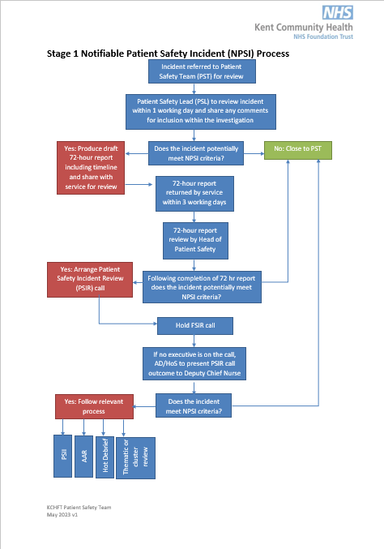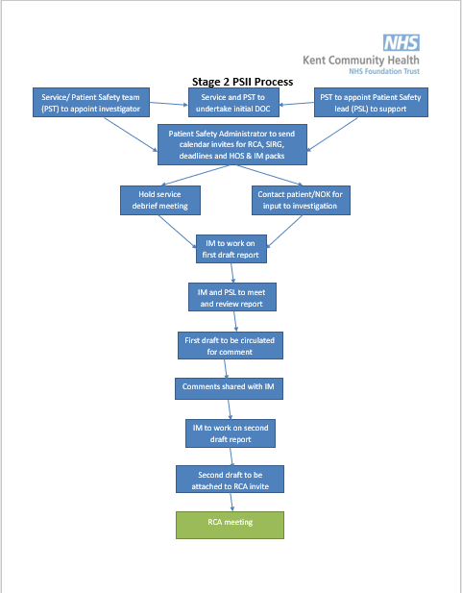
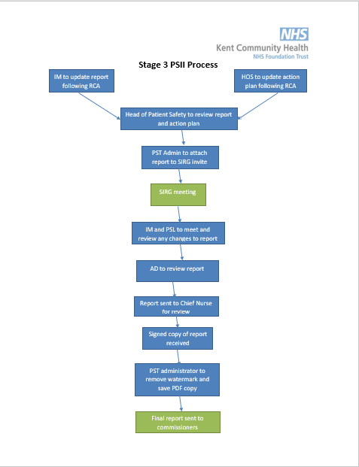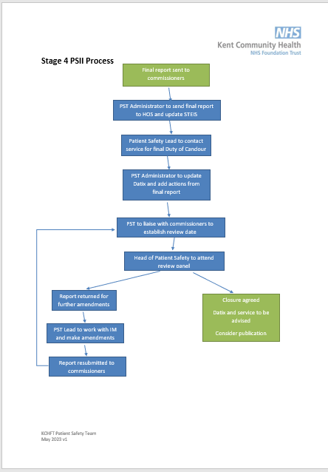

Appendix 3

