WORKFORCE DISABILITY EQUALITY STANDARD (WDES) REPORT
July 2022

1. Introduction

1.1 The NHS long term plan commits Trusts to becoming a model employer for Disabled people. This is seen as essential to guaranteeing the highest standards of care for patients. As an inclusive employer, KCHFT knows the value of a diverse workforce. We also recognise that the experience of our colleagues with a Disability is not always as positive as that of our colleagues without a Disability and are committed to changing this for the better. This is seen as essential to guaranteeing the highest standards of care for patients.
1.2 The national NHS Workforce Disability Equality Standard (WDES) report for 2021 published in May 2022 stated that 52,000 people in the NHS workforce (3.7%) declared a Disability through the NHS Electronic Staff Record. This is an increase of 6,870 (0.3%) compared to 2020.
1.3 Results of the national annual NHS staff survey (NHSSS) for 2020 show that Disabled staff consistently report higher levels of bullying and harassment and less satisfaction with appraisals and career development opportunities.
1.4 The WDES encourages the development of a more diverse, empowered and valued workforce and implementing it will support NHS organisations in complying with the provisions of the Equality Act 2010. Its purpose is to improve the experience of Disabled staff working for, and seeking employment in the NHS.
1.5 The WDES became mandatory following the revision to the 2018 NHS standard contract and came into force on 1 April 2019.
1.6 Underpinning the WDES is the "social model of Disability". This recognises that Disabled people face a range of societal barriers and these create Disability rather than the impairment or long-term condition.
1.7 There is a requirement for every NHS organisation to publish data annually showing the workplace experience of Disabled staff compared to non-Disabled staff following analysis of workforce information, staff survey results and Disability representation on Trust Boards. The analysis is undertaken against ten metrics.

2. WDES metrics
2.1 There are 10 WDES metrics:

• Three metrics focus on workforce data
• Five are based on questions from the national NHS Staff Survey (NHSSSS)
• One metric focuses on Disability representation on Boards
• One metric (metric 9) focuses on the voices of Disabled staff, 9b asks for evidence to be provided in the WDES annual report

2.2 The data used to report on the workforce metrics is taken from ESR either as a snapshot on 31 March 2022 or as data for the year up to this date.

2.3 The information used to report against the metrics concerned with the staff survey is taken from the 2020 NHSSS.

3. Demographics
3.1 Data from the National Office of Statistics for 2011, which asks people whether their day to day activities are limited because of a health problem or Disability which has lasted, or is expected to last, at least 12 months, shows that across England 17.9% of the population in England and Wales reported a Disability that limited their daily activities.
3.2 According to the 2011 Census, 17.6% of residents in Kent have a health problem or Disability which limits their day-to-day activities, in East Sussex it is 20.3% and in North East London it is 14.7%.

4. Workforce
4.1 At KCHFT an accurate picture is difficult to ascertain. Data held in the Electronic Staff Record (ESR) suggests that only 6.2% of colleagues have declared they have a Disability. This is an improvement on last years' figure of 4.9%. However, of those colleagues that completed the 2021 staff survey (836) 26% indicated they have a physical or mental health condition, Disability or illness that has lasted or is expected to last for 12 months or more. Work is currently underway aimed at addressing the difference in results reported on ESR compared to the results reported on the NHSSS. This includes encouraging colleagues to regularly review and update their ESR personal information via the self-service portal as their status may change throughout the life of their NHS career. However, it is important to note that the question in the staff survey is broader than the declaration of a Disability. Another important factor to understand is what is driving colleague reticence to reflect their Disability in their ESR record status.

5. Trust results
5.1 Metric one
5.1.1 Metric one represents the percentage of staff in AfC pay bands or medical and dental subgroups and very senior managers (including Executive Board members) compared with the percentage of staff in the overall workforce that have declared their Disability status.
The data in Tables 1 and 2 below shows the breakdown for clinical and non-clinical staff and grouped in different clusters.

Table 1
Non-Clinical Staff |  | DISABLED | NON-DISABLED | DISABILITY UNKNOWN OR NULL
Cluster 1 (Band 1 - 4) | Total | 6.6% | 89.2% | 4.2%
Cluster 2 (Band 5 - 7) | Total | 9.8% | 86.3% | 3.8%
Cluster 3 (Band 8a - 8b) | Total | 4.7% | 89.5% | 5.8%
Cluster 4 (Band 8c - 9 & VSM) | Total | 10.3% | 89.7% | 0.0%

Table 2
Clinical Staff |  | DISABLED | NON-DISABLED | DISABILITY UNKNOWN OR NULL
Cluster 1 (Band 1 - 4) | Total | 4.7% | 90.4% | 4.9%
Cluster 2 (Band 5 - 7) | Total | 6.7% | 90.0% | 3.2%
Cluster 3 (Band 8a - 8b) | Total | 4.1% | 93.1% | 2.8%
Cluster 4 (Band 8c - 9 & VSM) | Total | 0.0% | 93.8% | 6.3%
Cluster 5 (Medical & Dental Staff, Consultants) | Total | 5.9% | 88.2% | 5.9%
Cluster 6 (Medical & Dental Staff, Non-Consultants career grade) | Total | 1.3% | 93.4% | 5.3%
Cluster 7 (Medical & Dental Staff, Medical and dental trainee grades) | Total | N/A | N/A | N/A
NB figures are rounded to 1 decimal place to total %’s may not always total 100%
5.1.2 Figures 1 and 2 show an increase in the number of staff declaring a Disability over the years in ESR from 3.8% in 2018 to 6.2% in 2022 . Whilst this is an improvement, it is recognised that more work needs to be done to match the level of disclosure evident in the staff survey of 26%.
5.1.3 Figure 3 breaks down the percentage of staff by Disability and staff group, while figure 4 breaks the data down by Disability for clinical and non-clinical staff.
5.1.4 Figure 5 compares the data of Disabled and non-Disabled staff across the different pay bands in the Trust.

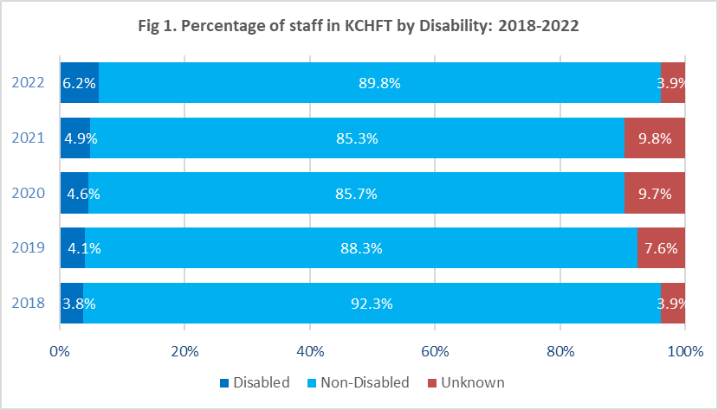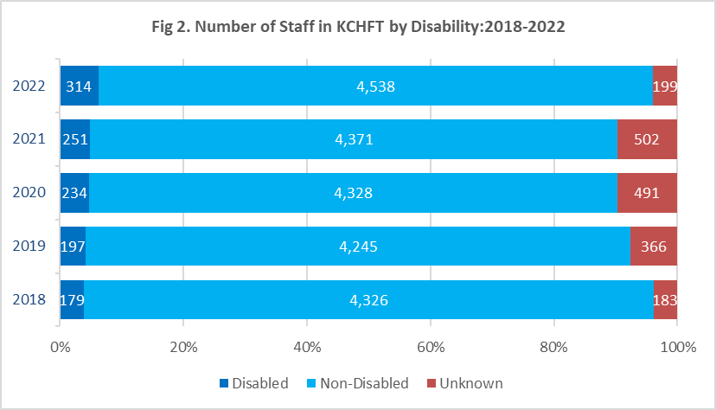
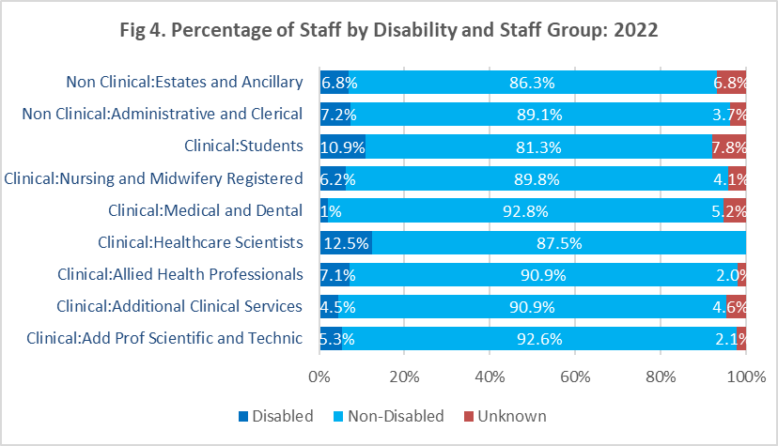
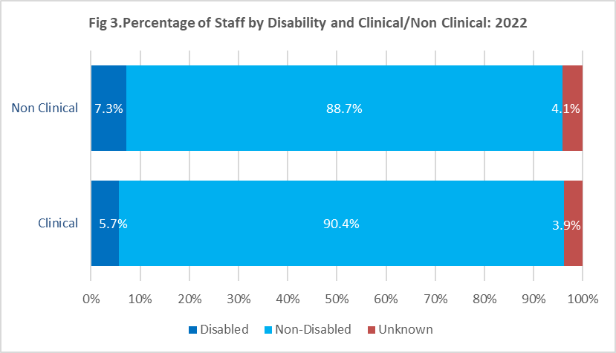

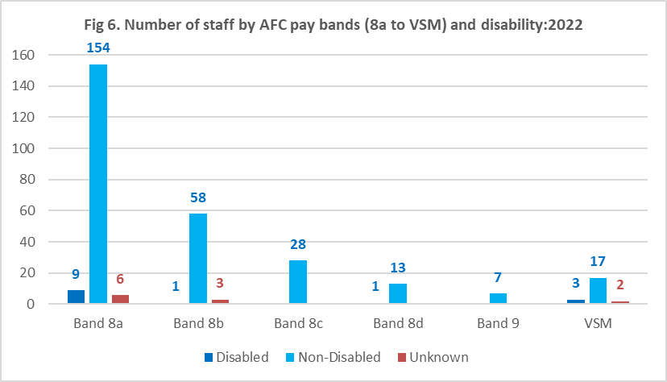

5.2 Metric two

5.2.1 Metric two examines the relative likelihood of Disabled people compared to non-Disabled people being appointed from shortlisting across all posts. The data refers to both internal and external posts advertised. The figure of 0.92 indicates that Disabled applicants are more likely to be appointed from shortlisting than non-Disabled applicants. This is really positive.

Table 3
 |  | 2020/2021 | 2021/2022
 |  | RELATIVE LIKELIHOOD
Relative likelihood of Disabled staff compared to non-Disabled staff being appointed from shortlisting across all posts | Total | 1.12 | 0.92

5.3 Metric three

5.3.1 Metric three looks at the relative likelihood of Disabled colleagues compared to non-Disabled colleagues entering the formal capability process, as measured by entry into the formal capability procedure based on data from a two-year rolling average of the current and previous years. The data excludes staff going through health-related capability processes.

5.3.2 The relative likelihood of Disabled colleagues entering a formal capability process compared to their non-Disabled colleagues is 2.28. This means Disabled colleagues are more likely to enter this process than their non-Disabled colleagues. There seems to be a big difference from the results reported last year of 0.915. However, one additional member of staff that may enter the capability process will greatly affect results. This may cause large fluctuations from year to year based on a difference of a small number of people. The information used to arrive at this figure is taken from the employee relations case management system, which contains equalities data taken from ESR. Therefore, this result may not be representative of the true picture because of the low declaration rates.

Table 4
 |  | 2020/2021 | 2021/2022
 |  | RELATIVE LIKELIHOOD
Relative likelihood of Disabled staff compared to non-Disabled staff entering the formal capability process, as measured by entry into the formal capability procedure | Total | 0.915 | 2.28

5.4 Metric four
5.4.1 Metric four looks at the percentage of staff experiencing harassment, bullying or abuse. The period covered by the 2021 survey shows that Disabled respondents are still reporting higher levels of harassment, bullying or abuse compared to non-Disabled respondents in all three aspects of the question on this topic.
Table 5
 |  | 2020 |  | 2021
a) Percentage of Disabled staff compared to non-Disabled staff experiencing harassment, bullying or abuse from: |  | DISABLED | NON-DISABLED | DISABLED | NON-DISABLED
i. Patients/service users, their relatives or other members of the public | Total | 21.0%% | 15.0%% | 23.9% | 17.7%
ii. Managers | Total | 12.2% | 6.4% | 9.9% | 6.4%
iii. Other colleagues | Total | 13.8% | 9.2% | 15.9% | 9.3%
b) Percentage of Disabled staff compared to non-Disabled staff saying that the last time they experienced harassment, bullying or abuse at work, they or a colleague reported it. The data for this Metric should be a snapshot as at 31 March 2020 | Total | 59.6% | 61.0%% | 62.1% | 59.0%

5.4.2 There was an increase of 2.9 % in the number of Disabled staff experiencing bullying, harassment or abuse from patients, relatives and service users. There was also a 3.2% increase of all staff being harassed by patients, relatives and service users. This seems like a large increase, however proportionately the position for Disabled colleagues has improved.
5.4.3 In 2020 Disabled staff were 1.4 times more likely to be harassed compared to non-Disabled staff. In 2021, Disabled staff were 1.35 times more likely to be harassed compared to non-Disabled staff.

Figure 7

5.4.4 When comparing KCHFT against our comparators in our staff survey benchmarking group*, Disabled and non-Disabled KCHFT staff experience less harassment, bullying, or abuse from patients/service users, relatives or the public.
Figure 8

*Benchmarking Group: Shropshire Community Health NHS Trust, Isle of Wight NHS Trust (community sector), Sussex Community NHS Foundation Trust, Bridgewater Community Healthcare NHS Foundation Trust, Norfolk Community Health and Care NHS Trust, Hertfordshire Community NHS Trust, Lincolnshire Community Health Services NHS Trust, Leeds Community Healthcare NHS Trust, Wirral Community Health and Care NHS Foundation Trust, Derbyshire Community Health Services NHS Foundation Trust, Hounslow and Richmond Community Healthcare NHS Trust, Dudley Integrated Health and Care Trust, Cambridgeshire Community Services NHS Trust, Birmingham Community Healthcare NHS Foundation Trust, Central London Community Healthcare NHS Trust, Kent Community Health NHS Foundation Trust

5.4.5 There was an improvement from last year, with fewer Disabled staff experiencing bullying, harassment or abuse from managers compared to non-Disabled staff.

Figure 9

5.4.6 When comparing KCHFT against our comparators in our staff survey benchmarking group*, Disabled and non-Disabled KCHFT staff experience less harassment, bullying, or abuse from managers.
Figure 10

5.4.6 There was a deterioration when examining the percentage of Disabled staff experiencing bullying and harassment from other colleagues.
Figure 11

5.6.7 When comparing KCHFT against our comparators in our staff survey benchmarking group*, Disabled and non-Disabled KCHFT staff experience less harassment, bullying, or abuse from other colleagues.
Figure 12

5.4.8 Disabled staff also indicated they or their colleagues were more likely, compared to their non-Disabled counterparts, to report when they had experienced bullying, harassment or abuse at work.
Figure 13

5.4.9 When comparing KCHFT against our comparators in our staff survey benchmarking group*, staff at KCHFT are more likely to report abuse which is really positive.
Figure 14

5.5 Metric five
5.5.1 Metric five asks what percentage of Disabled colleagues compared to non-Disabled colleagues believe that the Trust provides equal opportunities for career progression or promotion. There is little difference in the perception of promotions between Disabled and non-Disabled colleagues.
Table 6
 |  | 2020* |  | 2021
 |  | DISABLED | NON-DISABLED | DISABLED | NON-DISABLED
Percentage of Disabled staff compared to non-Disabled staff believing that the Trust provides equal opportunities for career progression or promotion. | Total | 66.9%* | 68.1%* | 66.9% | 67.5%

*Please note that the methodology for producing this metric has altered since 2020. An answer of 'Don't know' is now included in the denominator when in 2020 it was excluded. The figures for 2020 have been restated using the new methodology to allow for comparison.
5.5.2 In 2021, there was little or no change in this metric for both Disabled and non-Disabled colleagues compared to last year.
Figure 15
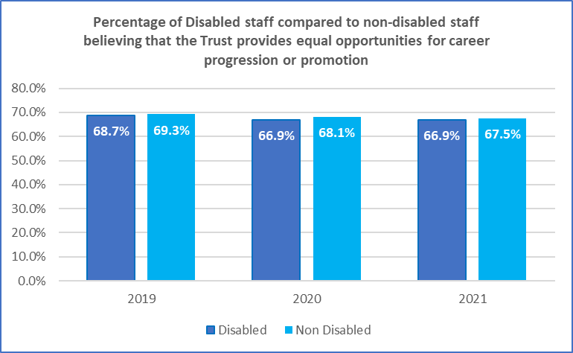

5.5.3 Disabled and non-Disabled colleagues who are employed by KCHFT favourably believe the Trust provides equal opportunities for career progression or promotion when compared to other benchmarked organisations*.
Figure 16

5.6 Metric six
5.6.1 Metric six asked what percentage of Disabled colleagues compared to non-Disabled colleagues said that they had felt pressure from their manager to come to work, despite not feeling well enough to perform their duties. 18.2% of Disabled respondents to the survey reported they had. This is lower than the previous year, and the disparity between Disabled and non-Disabled colleagues' experiences has narrowed. The Trust intends to continue to focus on how the experience of Disabled colleagues can be improved and how, overall, the Trust culture reinforces the need for rest, recuperation and a step away from presenteeism.
Table 7
 |  | 2020 |  | 2021
 |  | DISABLED | NON-DISABLED | DISABLED | NON-DISABLED
Percentage of Disabled staff compared to non-Disabled staff saying that they have felt pressure from their manager to come to work, despite not feeling well enough to perform their duties. | Total | 20.8% | 14.1% | 18.2% | 13.3%

5.6.2 When comparing KCHFT against our comparators in our staff survey benchmarking group*, KCHFT staff felt less pressure from their manager to come to work, despite not feeling well enough to perform their duties.
Figure 17

5.7 Metric seven

5.7.1 Metric seven looked at the percentage of Disabled colleagues compared to non-Disabled colleagues saying that they are satisfied with the extent to which their organisation values their work. The results have worsened for 2021 overall for both Disabled and non-Disabled colleagues. The gap in perception between Disabled and non-Disabled colleagues has reduced but further work in still needed in this area.

Table 8
 |  | 2020 |  | 2021
 |  | DISABLED | NON-DISABLED | DISABLED |  | NON-DISABLED
Percentage of Disabled staff compared to non-Disabled staff saying that they are satisfied with the extent to which their organisation values their work. | Total | 53.1% | 62.2% | 49.6% | 55.4%

5.7.2 The disparity in the perception between Disabled and non-Disabled staff has narrowed from 9.1% in 2020 to 5.8% in 2021.

Figure 18

5.7.3 When comparing KCHFT against our comparators in our staff survey benchmarking group*, KCHFT results are better than the benchmark.

Figure 19

5.8 Metric eight

5.8.1 Metric eight asked about the percentage of Disabled staff saying that their employer has made adequate adjustment(s) to enable them to carry out their work. 82.5% of Disabled colleagues responded that the Trust had made the adjustments needed. This figure has slightly worsened since the previous year, when 84.9% reported this to be the case. It is important for the Trust to explore whether this is a disproportionate impact of Covid-19, i.e. a step for many services into virtual or hybrid working, and the impact of PPE on colleagues with disabilities.

Table 9
 |  | 2020 | 2021
Percentage of Disabled staff saying that their employer has made adequate adjustment(s) to enable them to carry out their work. | Total | 84.9% | 82.5%

5.8.2 Overall, the results have not changed significantly over the past three years.
Figure 20

5.8.3 When comparing KCHFT against our comparators in our staff survey benchmarking group*, a larger percentage of KCHFT staff believe that the Trust has made adequate adjustment(s) to enable them to carry out their work than those of our benchmark comparators.

Figure 21

5.9 Metric nine
5.9.1 Metric nine is made of two parts. Part (a) compares the Trust's staff engagement score for Disabled staff and non-Disabled staff. Part (b) asks for evidence that the Trust has taken action to facilitate the voices of Disabled staff.
5.9.2 Part (a)
5.9.2.1 As can be observed in the table below there has been little change in engagement levels of Disabled colleagues in 2021 in comparison to the 2020 response.
Table 10
 |  | 2020 |  | 2021
 |  | DISABLED | NON-DISABLED | DISABLED | NON-DISABLED
a) The staff engagement score for Disabled staff, compared to non-Disabled staff |  | 7.2 | 7.5 | 7.1 | 7.3

5.9.2.2 KCHFT results are very similar to those in our benchmarking group*.

Figure 22
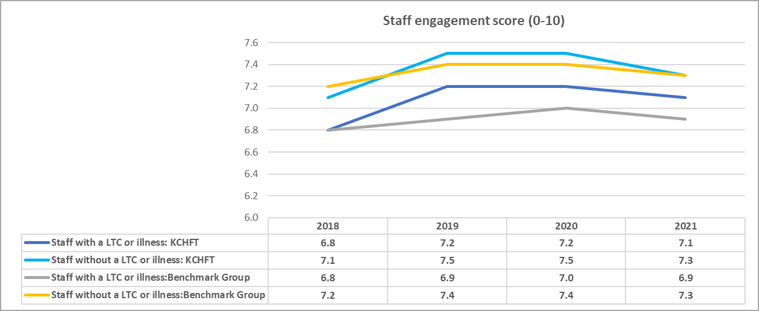
5.9.3 Part (b)
5.9.3.1 KCHFT is a Disability Confident Leader employer. The achievement was awarded in 2021 after providing evidence of how the Trust supports and empowers Disabled staff.
Table 11
 |  | DISABLED
b) Has your Trust taken action to facilitate the voices of Disabled staff in your organisation to be heard? (yes) or (no) |  | Yes

5.9.3.2 KCHFT has a workforce equality group comprised of HR, a Trade Union representative, management and staff network representatives, including the chair of the Disability and Carers network. The group meets bi-monthly to discuss issues related to workforce equality, diversity and inclusion and the staff network chairs are able to raise any issues or concerns from their network members.
5.9.3.3 Additionally, network chairs, including the chair of the Disability and Carers network, regularly meet with the Trust Chair, CEO and Director of People & OD to share issues and ideas and attend Strategic Workforce Committee on a rotational basis.
5.9.3.4 The Trust has an active Disability and Carers staff network. An executive sponsor supports the network and the members meet quarterly. Early discussions are ongoing to explore the creation of a Neurodiversity staff network.
5.10 Metric 10
5.10.1 Metric 10 asks about the percentage difference between the organisation's Board voting membership and its organisation's overall workforce. The data held in ESR suggests that Disabled colleagues are proportionally represented on the Board.
Percentage difference between the organisation's Board voting membership and its organisation's overall workforce, disaggregated is shown in Table 12 below:
Table 12
 | 2021 |  |  | 2022
 | DISABLED | NON-DISABLED | UNKNOWN | DISABLED | NON-DISABLED | UNKNOWN
Workforce | 4.6% | 85.6% | 9.8% | 6.2% | 89.8% | 3.9%
Voting Board Membership | 6.7% | 60.0% | 33.3% | 13.3% | 80.0% | 6.7%
Executive Membership of the Board | 25.0% | 75.0% | 0.0% | 37.5% | 62.5% | 0.0%
Difference (Voting Board Membership - Overall Workforce) | 2.0% | -25.6% | 23.5% | 7.1% | -9.8% | 2.7%
Difference (Executive Membership of the Board - Overall Workforce) | 20.4% | -10.6% | -9.8% | 31.3% | -27.3% | -3.9%

6. Areas for improvement
6.1 The identified areas for improvement arising after analysing the WDES data are:
- ESR is not reflective of the Disability status of trust colleagues, although there has been a 1.3% increase in last year's reported figures. Focus must be given to improving the accuracy and quality of the data within ESR, including encouraging and reassuring colleagues to share their status if they are reticent and to update their status if they become Disabled or experience a long-term health condition during their career at KCHFT. It is important to remember that status may change from recruitment / entry to the NHS and during the lifetime of a colleague’s career.
- Disabled colleagues are more likely to enter the formal capability process when compared to their non-Disabled colleagues. However, because of the small numbers involved, the results do not have statistical validity and should therefore be read with caution.
- Disabled colleagues responding in the NHSSS reported experiencing higher levels of harassment, bullying or abuse from patients, relatives or the public and that they were less likely to report this.
- In comparison to last year, there was a slight decrease in the number of Disabled staff compared with non-Disabled staff reporting levels of satisfaction with the extent to which the organisation values their work. However, a gap between the two groups must be addressed.
6.2 KCHFT are currently working on an action plan to respond to the issues highlighted in this report, which will be published in the coming months.

7. Conclusion
7.1 In conclusion, KCHFT has made some positive progress against many of the metrics in the past 12 months, but there is still work to do. We expect to see more rapid progress in the coming 12 months now that we have a dedicated resource in our Workforce EDI Manager, EDI Specialist and EDI Analyst.

7.2 Some positive findings are:

- The percentage of Disabled respondents reporting they felt pressured to come to work despite not feeling well enough to do decreased.
- The representation of Disabled colleagues at Trust Board and/or Executive Team level has increased when compared to 2021.
- Disabled staff are slightly more likely to be appointed from shortlisting.

7.3 A review of our existing EDI action plan, in light of the findings in this report, our WRES report and other feedback, is going to commence imminently with the view of a large-scale engagement with networks and colleagues to ensure the actions identified not only address the areas for improvement but resonate and are owned by those that live the experience within KCHFT.

8. Recommendation
8.1 The Executive is asked to approve this year's WDES data and report and action plan for submission and publication on the Trust website. The action plan will be added to the website once complete.

Workforce Disability Equality Standard 2021
² https://www.scope.org.uk/about-us/social-model-of-Disability/
Office for National Statistics
Disability in Kent Bulletin 2018
2011 Census Equalities… in brief
2011 Census: Long-term health problem or Disability, local authorities in England and Wales

