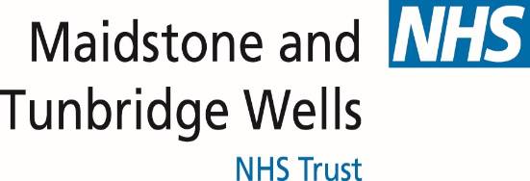
Hospital Passport
For people with learning disabilities coming into hospital
My name is:
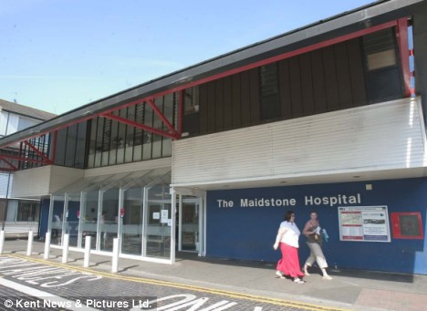
If I have to go to hospital this book needs to
go with me, it gives hospital staff important
information about me.
It needs to hang on the end of my bed and a
copy should be put in my notes.
This passport belongs to me. Please return it when I am discharged.
Nursing and medical staff please look at my passport
before you do any interventions with me.
Things you must know about me
Things that are important to me
My likes and dislikes

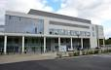
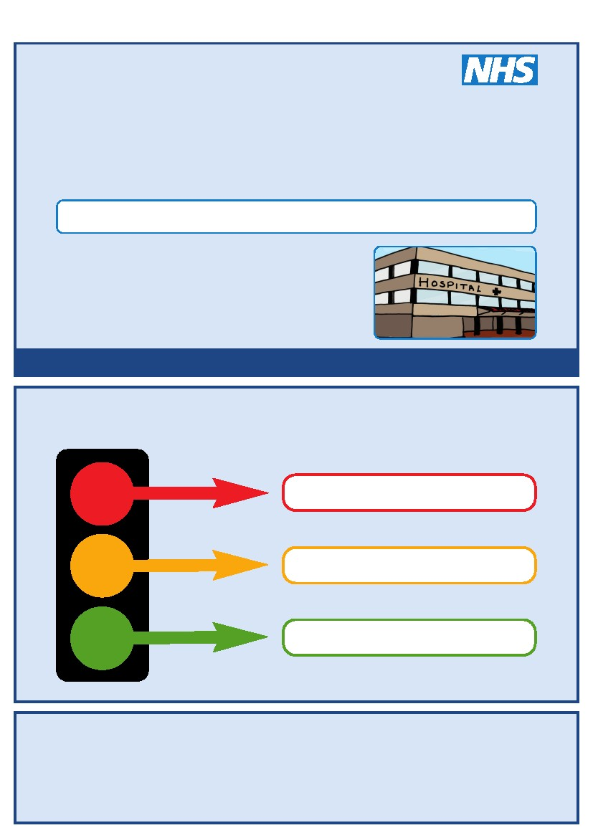
Things you must know about me
Likes to be known as:
NHS number:
Date of Birth:
Address:
Tel No
How I communicate/What language I speak:

Family contact person, carer or other support:
Relationship e.g. Mum, Dad, Home Manager, Support Worker:

Address:
Tel No:
My support needs and who gives me the most support:

My carer speaks:

Date completed By
1
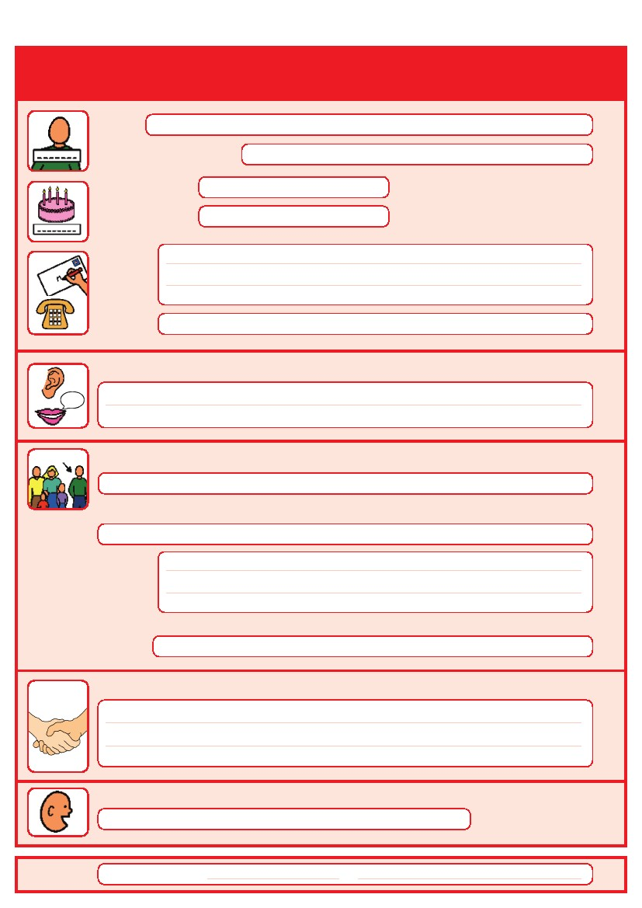
Things you must know about me
Religion:
Religious/Spiritual needs:

Ethnicity:
GP:
Address:
Allergies:
Medical Interventions – how to take my blood, give injections, BP etc.

Heart - No problems reported.
Risk of choking, Dysphagia (eating, drinking and swallowing):

Date completed
By
2
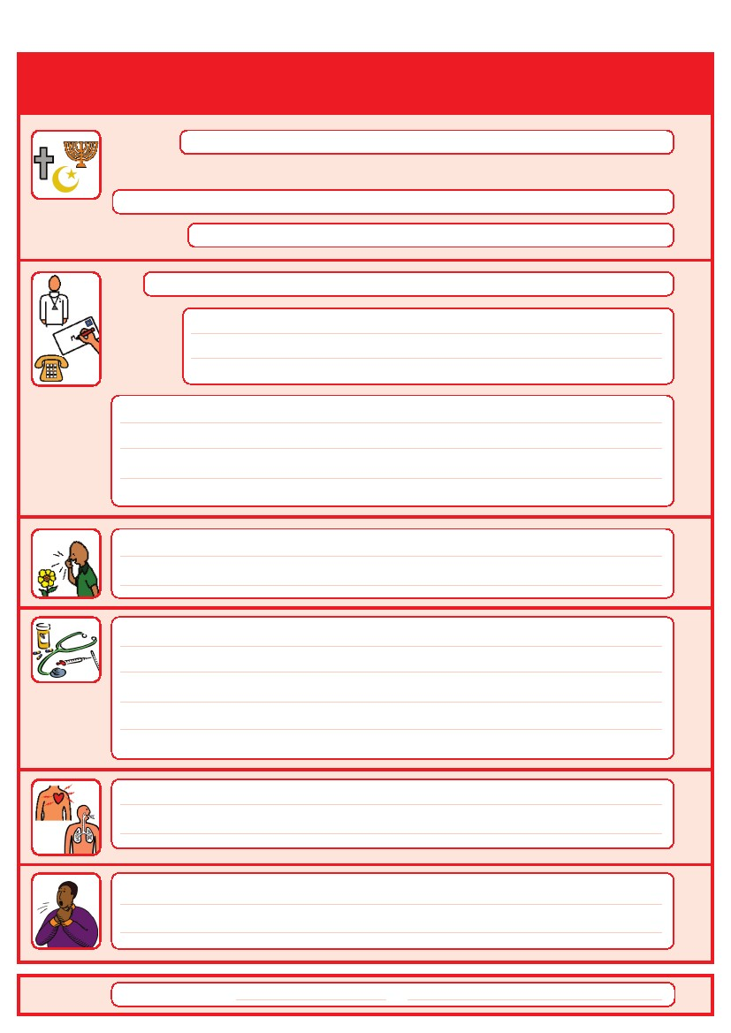

Things you must know about me
Current medication:

THIS MEDICATION MAY BE SUBJECT TO CHANGE, IT WAS CORRECT AT THE DATE OF COMPLETION.

My medical history and treatment plan:

What to do if I am anxious:

Date completed
By
3
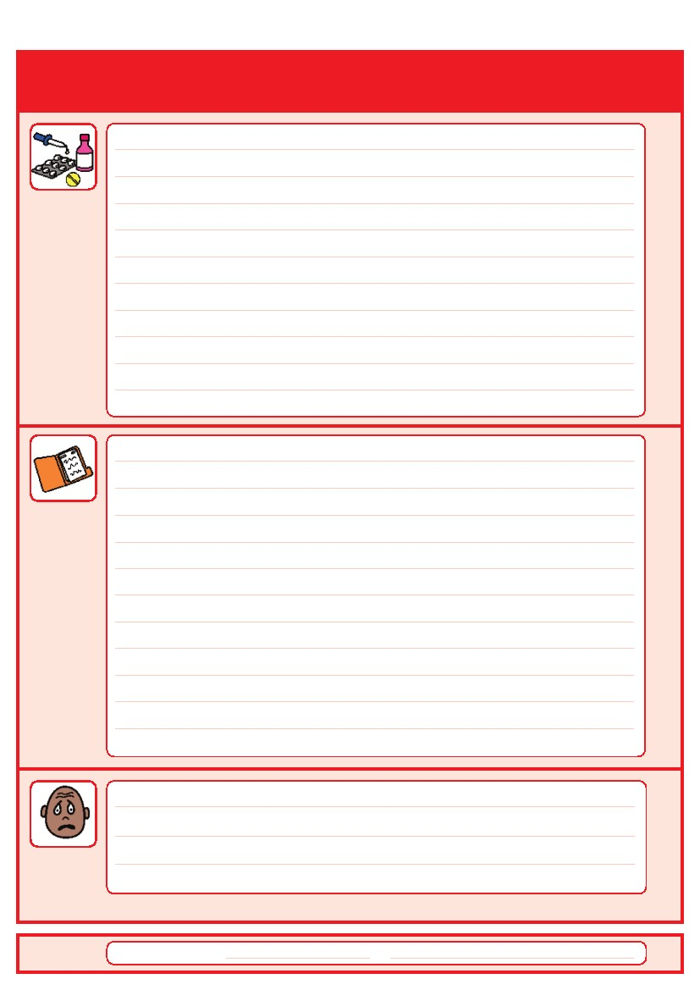
Date completed:

4

By:

Please clearly detail any interventions i.e Strategies that can prevent, please be explicit and include any care plans/risk assessments in place.
(Including known risks i.e. Sexulised behaviour,
Challenging Behaviour)
Risk Behaviours

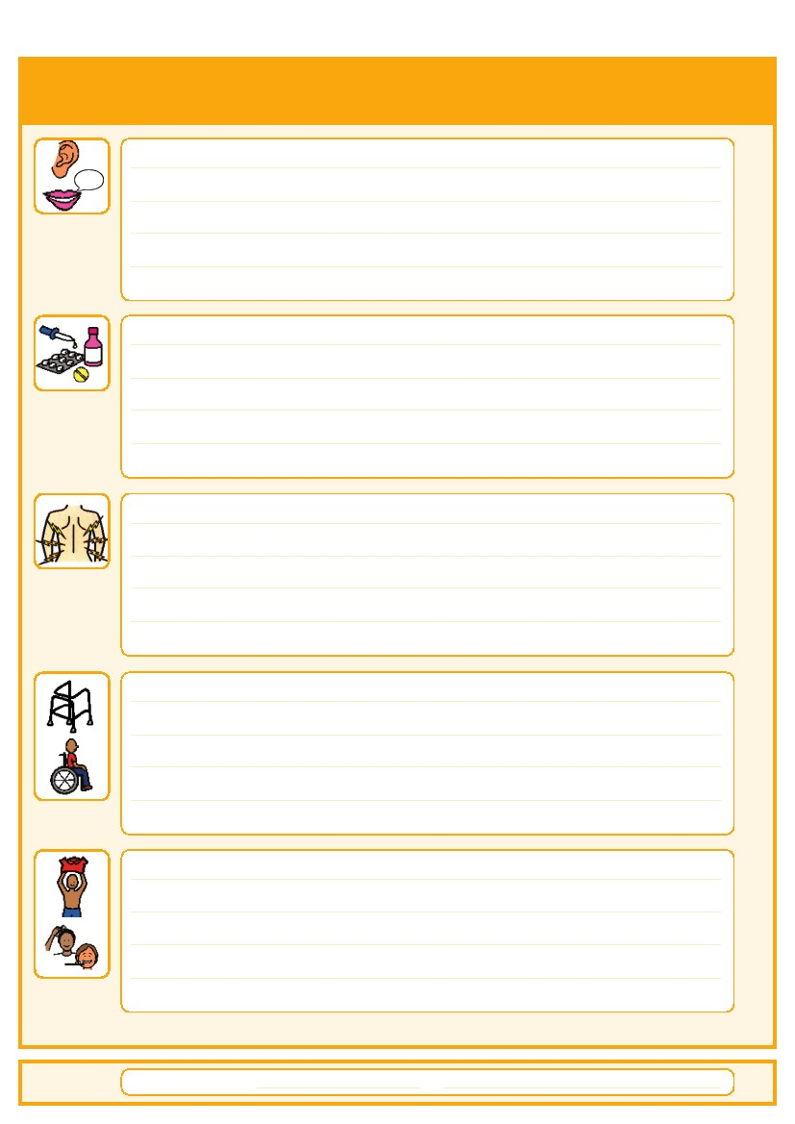

Things that are important to me
How to communicate with me:

How I take medication: (whole tablets, crushed tablets, injections, syrup)

How you know I am in pain:

Moving around: (Posture in bed, walking aids)

Personal care: (Dressing, washing, etc)

Date completed:
By:
5

Things that are important to me
Seeing/Hearing: (Problems with sight or hearing)
How I eat: (Food cut up, pureed, risk of choking, help with eating)

How I drink: (Drink small amounts, thickened fluids)

How I keep safe: (Bed rails, support with challenging behaviour)

How I use the toilet: (Continence aids, help to get to toilet)

Sleeping: (Sleep pattern/routine)
Date completed:
By:
6
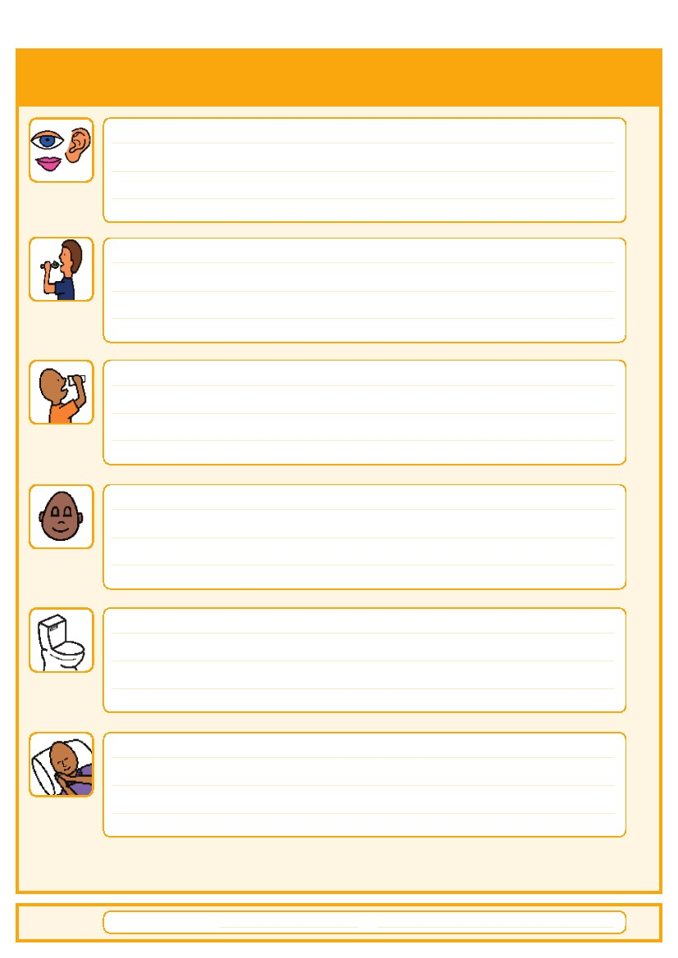
My likes and dislikes
Likes: for example - what makes me happy, things I like to do
i.e. watching TV, reading, music, routines.
Dislikes: for example - don’t shout, food I don’t like, physical touch.
Things I like
Please do this:

Things I don’t like
Don’t do this:

Date completed:
By:
7
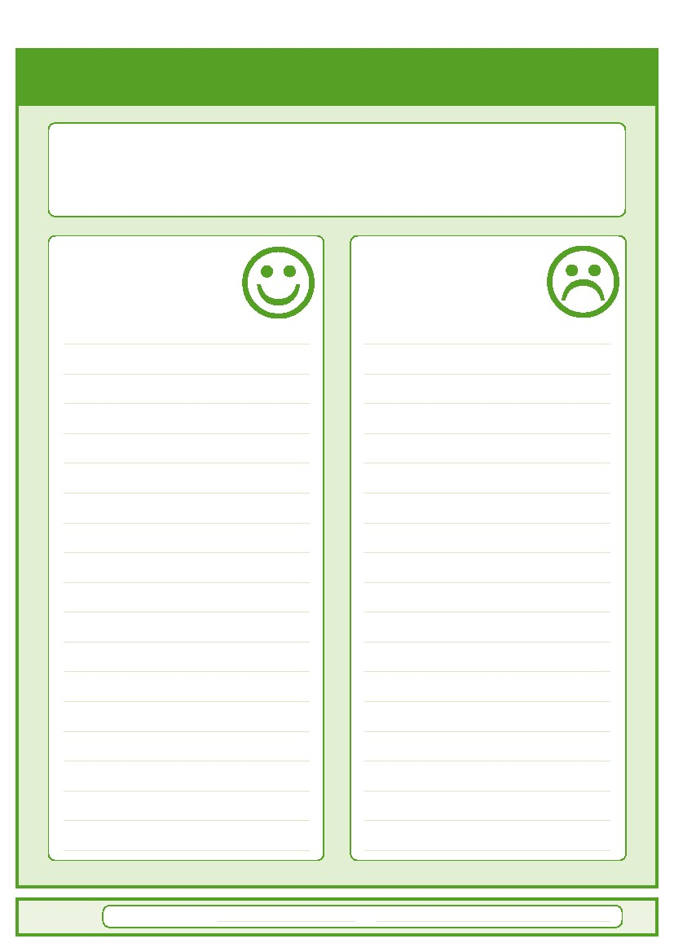
Notes

8

9
Please contact your local community learning disability team if you have any questions about the passport:
This Hospital Passport is based on original work by Gloucester Partnership NHS Trust and a second
Version adapted by the Corporate design department at Wandsworth Council

