**mouth**

**Healthy mouth, safer swallow  
It’s as easy as ABC**

**A guide to mouth care for carers of adults with special needs and swallow difficulty.**

* **Avoid sugar – reduce the amount and frequency of food and drinks containing sugar**
* **Brush – thoroughly twice a day**
* **Check-ups – have regular dental appointments – as advised by your dentist**

**Why is oral health so important?**

By **oral** we mean the **whole mouth**, **including teeth, gums, lips, tongue and cheeks.**

Oral health means more than just having good teeth. It is a major part of general health and wellbeing.

A healthy mouth is important for many everyday functions, such as:

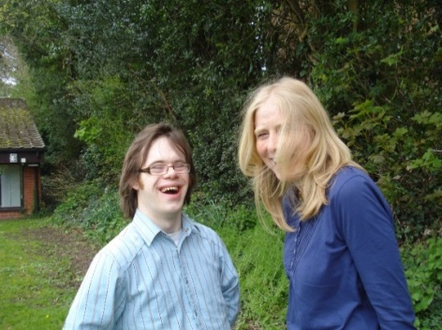



kiss 1

**Eating and drinking**

**Laughing and smiling**

**Kissing**

**Chatting and making friends**

**toothachesmelly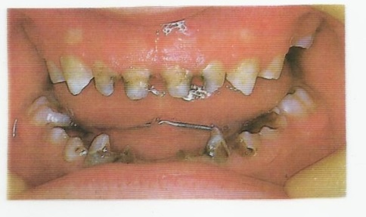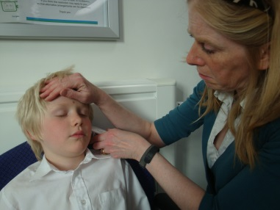Poor oral health can lead to:**

**Pain, infection and tooth loss**

**Poor appearance**

**Bad breath**

**Ill health**

**Avoid sugar**

**Reduce the amount and frequency of food and drinks containing sugar. Keep them to mealtimes only.**

**Dental Decay** is caused by sugar in the mouth that is broken down by plaque bacteria to form acid, which attacks the teeth.

**Plaque** is the sticky, creamy film of bacteria that continuously forms in the mouth.

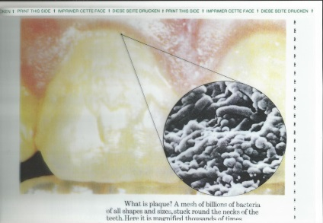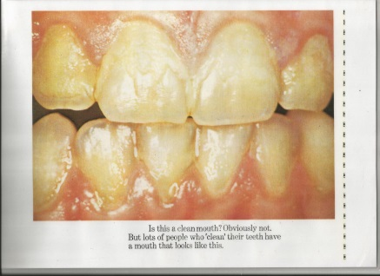

Sugar + bacteria = acid

Acid + tooth = decay

**toothache**The more often sugary foods or drinks are consumed, the higher the risk of decay.



**=**

**Top tips for decay prevention**

* Keep sugar, in any form (e.g. glucose, sucrose, fructose, maltose, honey, maltodextrin) to mealtimes only.
* Between meals, stick to sugar free snacks and water.
* Remember that smoothies contain sugar too.
* Ask for sugar free medicines, if available.
* Avoid any food or drinks (other than water) after brushing teeth last thing at night.
* Some thickening agents contain maltodextrin, which can cause decay. Clean the mouth after drinks. Follow speech and language therapy guidelines and seek advice from your dentist.
* Always check labels for the ingredients.

**Dental Erosion** is slightly different to dental decay, but just as damaging.

It is the softening of the tooth surface by frequent acid contact and can cause pain and discomfort.

It can be caused by acidic drinks (such as fruit juice and fizzy drinks), acidic foods, and frequent acid reflux or vomiting.

Lemon and glycerine mouth swabs can lead to erosion and should **not** be used.

**Saliva** helps to neutralize the acid from both the decay process and erosion, but this takes time.

It also helps to harden the softened tooth by replacing minerals removed by acid.

It is important not to brush immediately after acidic foods, drinks or vomiting, as this could remove the softened tooth surface before the saliva can repair it. It is best to wait about 30 minutes. You could rinse your mouth with water in the meantime, if safe to do so.

**30 minutes later**

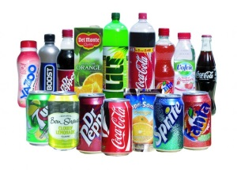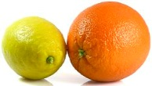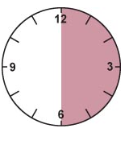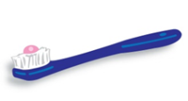

**Brush twice a day**

**Top tips for tooth brushing**

Brush teeth twice a day (last thing at night and at one other time).

morningevening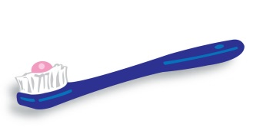

**Fluoride** helps to protect teeth from decay. Use fluoride toothpaste, containing 1,350 – 1,500 parts per million fluoride (ppm F). Fluoride helps to protect teeth from decay.

You can find this printed on the tube.

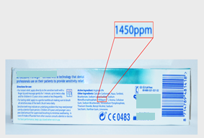

If someone has swallowing difficulties it can help if the toothpaste doesn’t foam too much. Your dentist may prescribe high fluoride toothpaste if required. Some people don’t like strong mint flavours or have a dry mouth. Use a non-foaming toothpaste (without sodium lauryl sulphate). All available at the pharmacy and most supermarkets or Dentocare www.dentocare.co.uk.

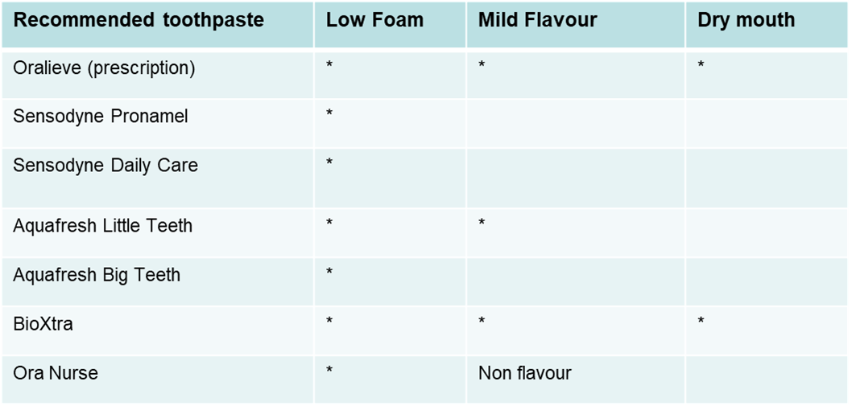

No flavour

**Top tips for brushing for someone else**

The person should be sitting with their chin slightly tucked in to help protect the airway. Stand behind and slightly to the side.

It can be difficult to brush someone else’s teeth if they struggle to cope with it. Do the best you can. **Anything is better than nothing.**

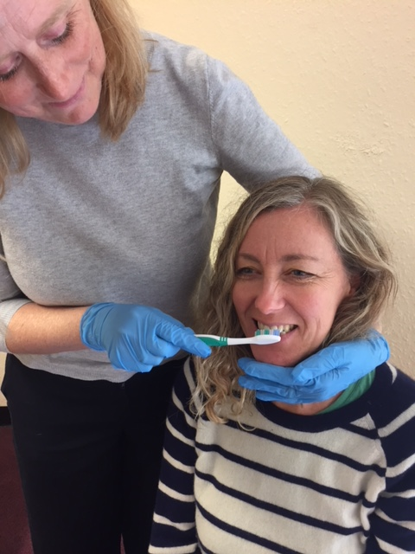

**Brush teeth twice a day**

* Use a small headed toothbrush with soft – medium bristles.
* Use a pea sized amount of fluoride toothpaste.

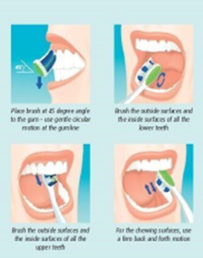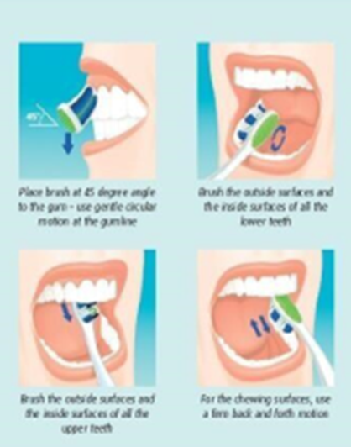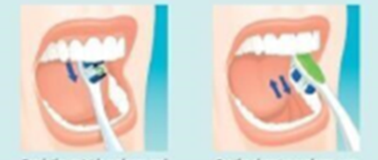

* Use small circular movements.
* Brush all surfaces of all the teeth.
* Brush all biting surfaces using a gentle scrubbing action.
* Gently brush the tongue surface from the back to its tip if possible. This will help to remove debris and bacteria and keep your mouth clean and healthy.
* If possible clean between the teeth with waxed dental tape or small interdental type brushes such as ‘TePe’. Your dentist or hygienist can advise you how to use these.

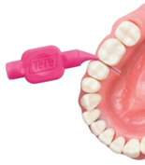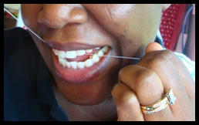

* If gums bleed don’t stop brushing. Carry on brushing in the correct way. Gums that bleed can be the first sign of gum disease caused by plaque. This plaque needs to be thoroughly removed by correct brushing.

After brushing, spit, **don’t rinse**, or wipe the excess with a tissue or flannel, this prolongs the effect of fluoride on the teeth.

Rinse the toothbrush under clean running water and leave to air dry.

Tooth brushing is still important for people who are tube-fed, to keep the mouth clean, comfortable and pain free. It will also help to prevent bad breath and reduce the build-up of hardened plaque (calculus / tartar) on the teeth.

**Helpful hints**

Replace your toothbrush regularly (approximately every 3 months) or sooner if the bristles become splayed or damaged.

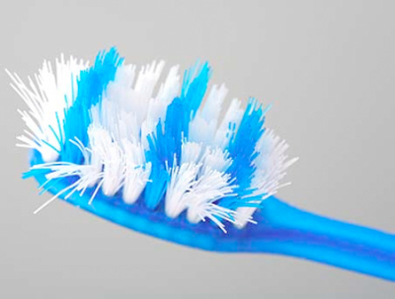

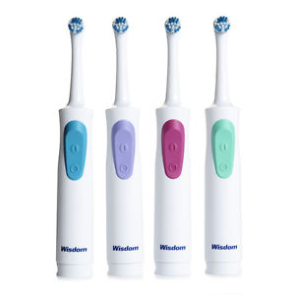

You could use an electric toothbrush.

If someone struggles with tooth brushing and can only cope for a limited time, you could try a three headed Dr Barman’s ‘Superbrush’ that cleans several surfaces at once.

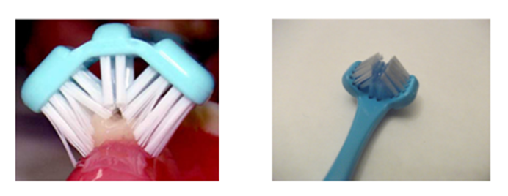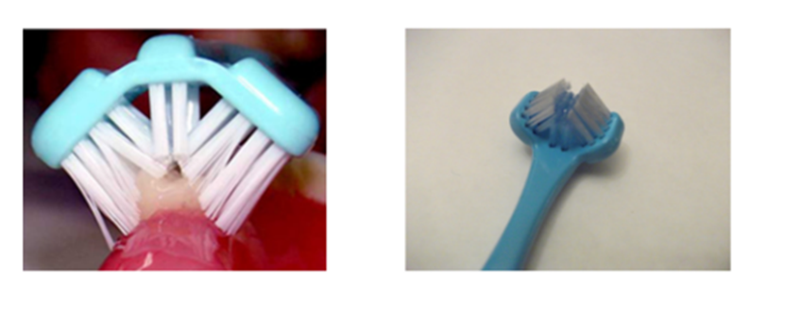

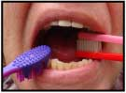

A mouth prop can be helpful if biting the toothbrush is a problem.

Two brushes can be pushed together as a prop to help keep the mouth open.

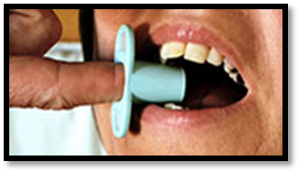Plastic finger guards are also available from www.dentocare.co.uk

These can be used as a prop to keep the mouth open during tooth brushing.

**Top tips for someone with no teeth**

* ****It is important to clean the mouth to keep comfortable, fresh and free from infection.
* Use a moistened soft toothbrush or a Mouth Cleanser sometimes known as ‘Moutheze’
* Moisten with water and gently sweep around the mouth, gums, inside cheeks, lips and tongue.

**Top tips for dry mouth**

A dry mouth is uncomfortable. Saliva is essential, for speech, chewing and swallowing and maintaining a healthy comfortable mouth. Some toothpaste helps to relieve a dry mouth. See toothpaste table on ‘Top tips for tooth brushing’.

* Use water based oral gel or spray to lubricate a dry mouth.
* Use a soft toothbrush, Mouth Cleanser (MC3) or a gloved finger to gently spread a thin coating of gel around the inside surfaces of the mouth including the tongue.
* This can also help with dry lips.
* Avoid petroleum or paraffin based products as these are toxic to the lungs if aspirated.

Examples of oral gels and sprays:

* Oralieve (www.oralieve.co.uk or on prescription from your GP).
* BioXtra or Biotene (available from the chemist).

Ask your pharmacist for advice.

**Mouth Cleansers: Mc3**

* These are a safe alternative to foam swabs.
* They are used to remove food debris and mucous from the mouth.
* They are used to freshen and moisten the mouth.
* They can be used to apply oral gel.
* They are not a substitute for toothbrushes and are **not** effective in cleaning teeth.
* They can be used wet or dry.

After use, clean and rinse under cold running water and leave to air dry, discard after 12 hours, or sooner if damaged or full of debris.

These can be purchased online or from NHS supplies.

**Top tips for denture care**

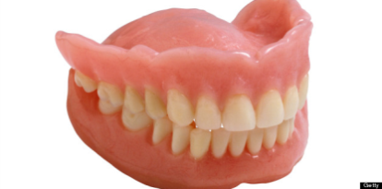

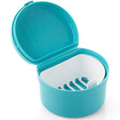

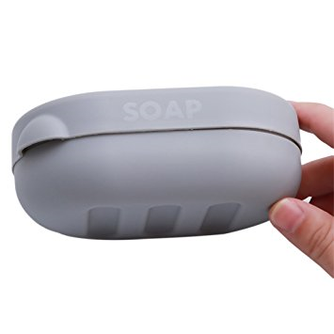

* If a person wears dentures, these should be taken out of the mouth before brushing any natural teeth.
* If the person has no teeth, use a soft toothbrush, a clean damp flannel or a mouth cleanser to clean the mouth.
* 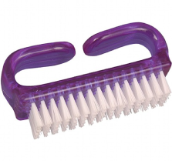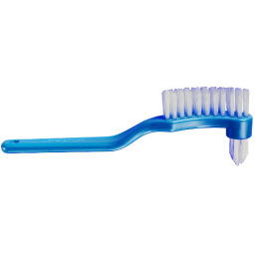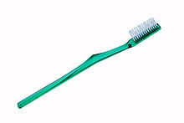Dentures need to be cleaned with a denture brush, toothbrush or even a nailbrush (which may be easier to hold).
* Use either denture paste or unperfumed soap and water.   
  **Do not** use toothpaste as it is too abrasive and will scratch the plastic.
* Clean the dentures over a basin of water or towel to protect them if they are dropped.
* Rinse the brush you have used under clean running water and leave to air dry.
* Dentures should be removed at night, to give your mouth a rest. The clean dentures should be stored in a container with a little fresh, clean water, to prevent them from drying out and becoming brittle. If using a specific denture soaking solution make sure you follow manufacturer’s instructions.
* If dentures are loose or uncomfortable you should see your dentist.

**Check up regularly**

Regular dental checks are essential for good oral health. Your dentist will advise you how often this should be.

If someone has no natural teeth, it is still important to have regular dental checks to make sure the mouth is healthy. A dentist must also be contacted if anyone has any problems with their teeth or dentures.

Between visits, if someone experiences pain, or if you notice anything unusual in an individual’s mouth lasting longer than 2-3 weeks, it is important to contact a dentist. Look out for ulcers; red or white patches or any unusual lumps in the mouth.

If you are unable to access your usual family dentist due to a special need, you can be referred to the Community Dental Service by any health professional.

**Referrals can be sent to:**

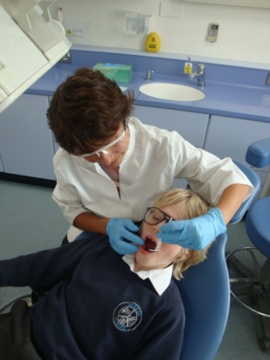**NHS Dental Services**

**Capital House**

**Jubilee Way**

**Faversham**

**ME13 8GD**

**For further information call:**

**0330 123 9438**

**Finally…**

Everyone has the right to a clean healthy mouth that is comfortable and pain free.

By establishing regular, thorough oral hygiene and following the above advice, this should become routine, familiar and easier to achieve.

The copyright of the symbols used belongs to the Trustees of the Makaton Vocabulary Project 2007

Widgit Software

The Picture Communication System, Mayer Johnson LLC

These symbols cannot be reproduced without their permission.

The leaflet is the property of the Speech and Language Therapy Service and the NHS Community Dental Service.

**mouthHealthy mouth, safer swallow  
It’s as easy as ABC**

* **Avoid sugar – reduce the amount and frequency of food and drinks containing sugar**
* **Brush – thoroughly twice a day**
* **Check-ups – have regular dental appointments – as advised by your dentist**

**Your own notes…**

**_________________________________________________________________  
  
_________________________________________________________________  
  
_________________________________________________________________  
  
_________________________________________________________________  
  
_________________________________________________________________  
  
_________________________________________________________________  
  
_________________________________________________________________  
  
_________________________________________________________________  
  
_________________________________________________________________  
  
_________________________________________________________________**

**Need help?**



**Our Patient Advice and Liaison Service   
(PALS) can help you.**You can ask a question or tell them if   
you are unhappy about something.



**Phone:** 0300 123 1807   
The team can phone you back.

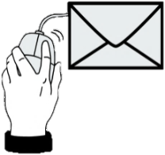

**Email:** kentchft.PALS@nhs.net

**Post:**

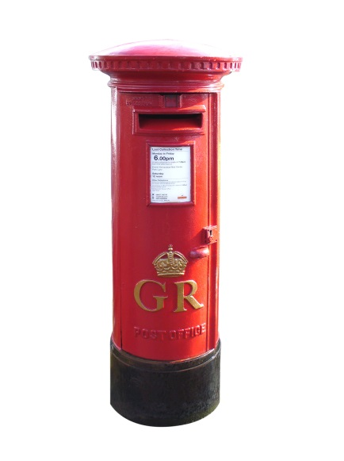

Patient Advice and Liaison Service (PALS)

Kent Community Health NHS Foundation Trust

Unit J, Concept Court

Shearway Business Park

Folkestone

Kent CT19 4RG

00700  
Review in February 2022  
11.10.19

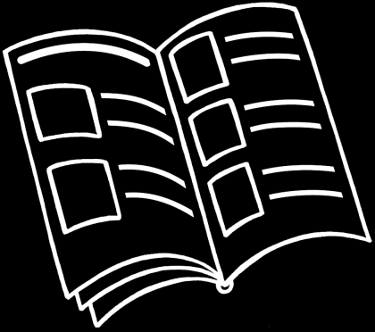

**easy read**



**Our information is made with help from people with a communication need. Created using CHANGE and stock images.**