Meal time swallowing observation form for care/nursing staff
Please note that this swallow observation form is for you to carry out before a phone assessment session with an SLT.
We advise watching the resident having a meal in the environment where they usually eat.
Please complete the form with as much information as you can and once completed, please email back to the SLT service at kentchft.aslt@nhs.net.
When you return this form to us the information will be reviewed by an SLT. A phone or video consultation appointment with an SLT will then be arranged. During this consultation, we may need to ask you more questions and also may ask you to carry out some things with the resident to help us understand more about their swallowing problem.
The information you give us on this form will help us to make a plan to provide advice and guidance on how to reduce the risk of food/fluid going down the wrong way and minimise coughing/choking and/or chest infections. It will help to ensure that their eating and drinking is as safe and comfortable as possible.
Patient’s name: | NHS number:
Date of Birth: | Name and job title/role of person observing the mealtime and completing the form:
Date form completed:

Covid-19 status: Positive ☐ Suspected ☐ Negative ☐ Unknown ☐
NB. If Covid status is positive/suspected, take appropriate precautions during mealtime observation in addition to PPE, e.g. stand to the side, behind or observe the resident from 2m away if possible, particularly if there is a history of coughing on food/drink.
 | Please give as much information/description as you can
What is the resident currently eating and drinking in terms of texture/thickness?  If they have some foods or drinks of a different texture, please give details (eg. if some snacks are different to main meals, or if meat portion is pureed but other foods are minced)  What other strategies and techniques are being used? E.g. hand over hand feeding, reminders to swallow | Drinks: Thin drinks (Level 0) / Slightly thick (Level 1) /  Mildly thick (Level 2) / Moderately thick (Level 3) /  Extremely thick (L4)  Food: Regular diet (Level 7) / Easy to chew diet (EC) / Soft & bite-sized (Level 6) / Minced & moist (Level 5) /  Pureed (Level 4) / Liquidised (Level 3)  Strategies:  Positioning:  Equipment:  Level of help /supervision:
Were these recommendations made by an SLT? | Yes☐ No☐
What is the current condition of their mouth? Do the lips/ tongue and/or lining of the mouth appear dry?

What mouth care do they receive and how often?

How are they currently managing with swallowing food and drinks?

What are your concerns/why have you referred them to SLT?

Have they had any episodes of coughing/choking? | Coughing: Yes☐ No☐  Choking (i.e. food sticking in throat): Yes☐ No☐  If yes, how frequently does it happen and on what food or drink does it happen:
Have they had any recent or recurring chest infection? | Yes☐ No☐  Give details of when, how often, treatment etc:
What is the current condition of their mouth? Do the lips/ tongue and/or lining of the mouth appear dry?

Any drooling of saliva?

What mouth care do they receive and how often?

How is their weight? | Losing weight ☐ Gaining weight☐ Stable weight☐  Give details:
Any concerns about fluid intake?
Is a dietitian already involved? | Yes☐ No☐
Are they on an oral nutritional supplement? | Yes☐ No☐  If yes, which ones and how many per day:
Observations before the meal:
Please comment on their positioning, the cleanliness of their mouth, fit of dentures, alertness and ability to feed themselves:

Observations during the mealtime
What food and drink are you observing them eating and drinking for this meal?

Swallowing difficulties/symptoms observed: | Please state the food and/or drink that you notice any difficulty with:
No problems☐

Food/drink falling out of the mouth☐

Chewing difficulty ☐
e.g. weak, slow, effortful
Food remaining in mouth after swallowing ☐
Are they aware of food residue? Yes ☐ no ☐ | If yes, can they clear it and how
Shortness of breath☐

Reported feeling of sticking of food ☐ | Ask them to point to where it feels like it is sticking and tell us where they point to, e.g. throat / voice box, Adam’s apple area / below Adam’s apple:
Lots of swallows needed per mouthful of food ☐
Burping ☐
Regurgitation ☐

Any meal time behaviours noted such as overfilling mouth, talking with mouth full, drinking too fast, spitting out? ☐

Any other observations during the meal?: e.g. gets tired,
Do you observe any: | If you noticed these signs which food/drink was it with and when did it happen e.g. immediately/during or after swallowing. Was it happening even before they had anything to eat and drink?
Wet voice quality/sounds gurgly ☐
Throat clearing ☐

Coughing ☐

Choking ☐

Did anything else seem to help make this resident safer when eating and drinking?

Thank you for completing this observation form.

IDDSI food name & level | Food texture
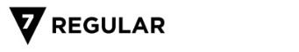 | No restrictions
EASY TO CHEW  EC | This is for people who need soft moist food but do not need all food cut into bite-sized pieces before serving. No bread unless advised by SLT
 | Food is soft, tender and moist but needs some chewing. All foods are cut into bite-sized pieces before serving (bite-sized = 1.5cm square , approx. thumb nail-sized.) Small pieces of soft, tender or finely minced meat. No bread unless advised by SLT
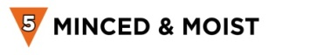 | Must be mashed prior to reaching patient. Food is soft, tender and moist and needs very little chewing. Meat must be finely minced or puréed. Any lumps must be small enough to pass through the prongs of a fork (max 4mm). No loose fluid, mixed textures or bread.
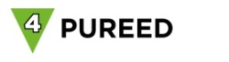 | Completely smooth throughout with no lumps/bits and is moist. Holds its shape on a plate and can be eaten with a fork. Does not require chewing and cannot be poured.
 | Completely smooth throughout with no lumps/bits. Can be poured. Does not hold its shape on a plate. Cannot be eaten with a fork, falls through the prongs.
IDDSI drink name and level | Amount of Resource ThickenUp Clear powder to be added per 200 mls of drink + description of drink
 | n/a | Flows fast like water
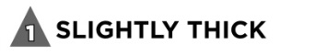 | 1 scoop | Thicker than water
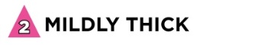 | 2 scoops | Flows quickly off a spoon but slower than thin drinks. Some effort is required to drink this through a straw**
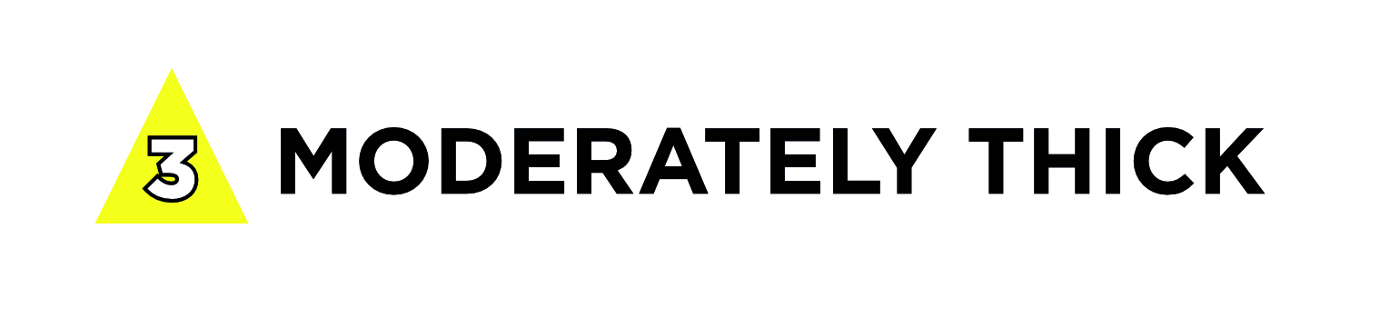 | 4 scoops | Pours easily but slowly from a spoon. Can be drunk from a cup. Effort is required to drink this through a straw**
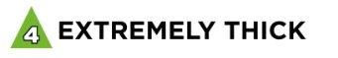 | 8 scoops | Falls off spoon in a single spoonful when tilted. Cannot be drunk from a cup or be sucked through a straw.

Reference list of food and drink textures

