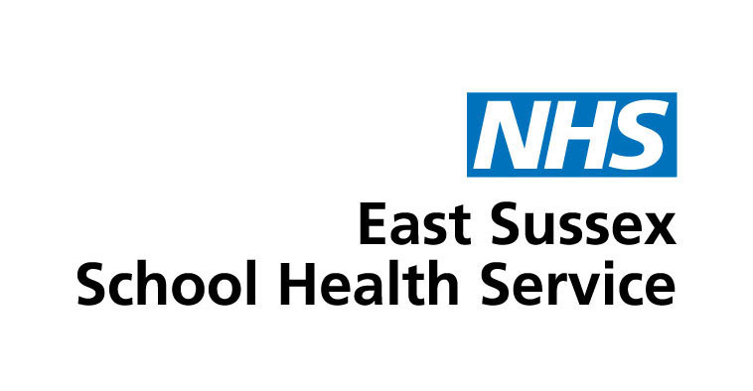

Draft website copy for primary school websites

Below is draft copy for you to use on your school website to help promote the School Health Service.

If you have any questions or need support please email:

Communications and Marketing Team
Kent Community Health NHS Foundation Trust’s
01622 211946
kchft.comms@nhs.net

Primary school

Your child’s School Health Service
When your child started school, the East Sussex School Health Service took over their health care from the Health Visiting Service. They will continue to look after them until they are 19.

Who are they?
The team consists of school nurses, school staff nurses, health improvement staff, nursery nurses, school nurse assistants, associate practitioners and secretarial support. All school nurses are qualified nurses with specialist training in public health.

What do they do?
The team works hard to improve the general health and wellbeing of children, young people and their families and they do this in many ways, at home, in school and at community based venues.
The service they provide has been designed with the involvement of children, young people and their parents and carers.
They are responsible for delivering national child health initiatives such as:
- Health assessments for children in reception and in year 6 to help parents or carers identify anything that may impact on a child’s ability to achieve their potential
- Vision and hearing screening
- National Child Measurement Programme
They offer expert advice, support and help, sometimes in partnership with specialist services when needed, on issues such as:
- daytime and night time wetting and soiling
- behaviour management
- healthy eating and lifestyle
- emotional health and wellbeing
- puberty and growing up
- sexual health
- stopping smoking
- drug and alcohol misuse
- sleep
- complex health needs
- weight management

How to contact your child’s School Health Service
The team is available Monday to Friday, 8.30 am to 5pm, including school holidays.
They can be contacted by parents, teachers, children and young people and other health care professionals such as GPs.
0300 123 4062
kentchft.esschoolhealthservice@nhs.net
Link to our website

