Midweek meals on a budget recipes:

Stir fry sweet and sour chicken with noodles (based on Change 4 Life recipe)

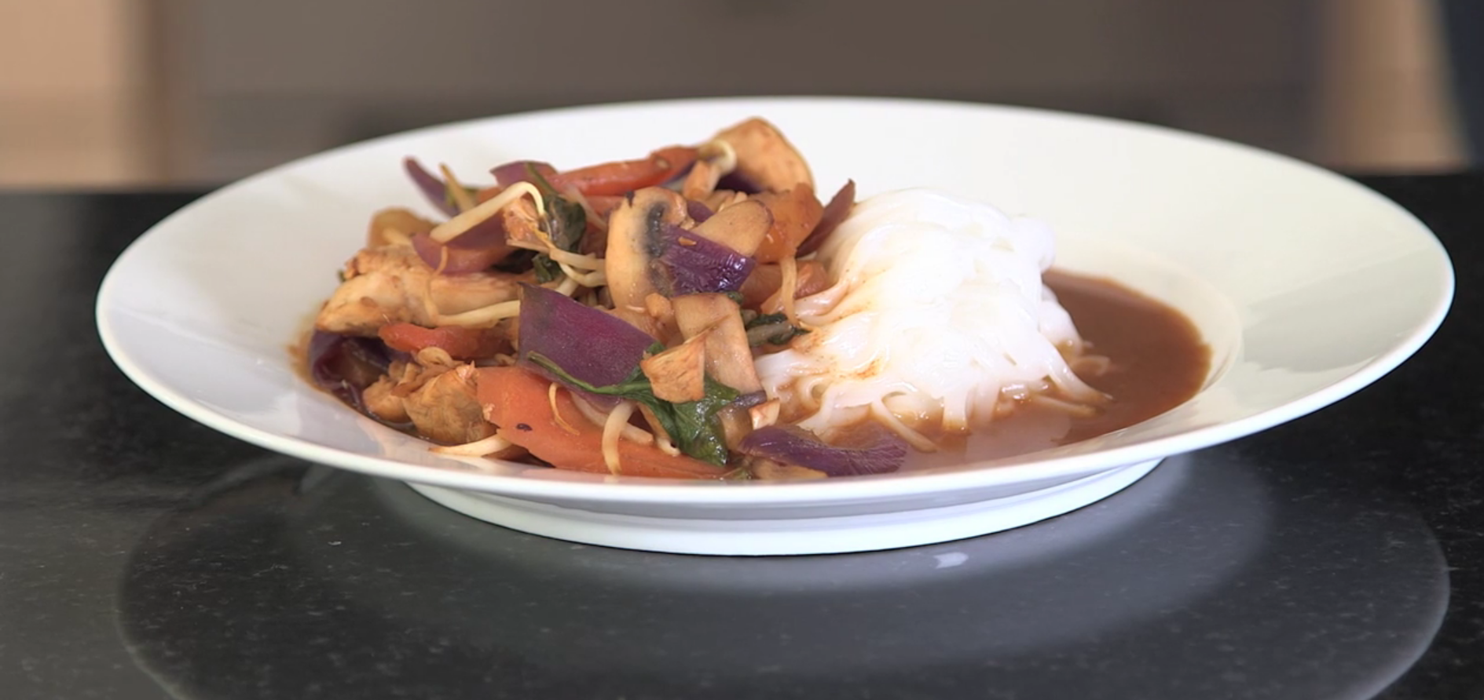

A great alternative to using jars of sauce which can be high in sugar, fat and salt – make your own for a fraction of the cost!

You will need:

150g easy cook white or brown rice
1 tin (227g) pineapple pieces in natural juice
1 tablespoon cornflour
2 teaspoons tomato puree
1 teaspoon soy sauce (reduced salt is best)
2 teaspoons vegetable oil
300g skinless uncooked chicken (thigh or breast) cut into chunks
1 onion - sliced
1 pepper deseeded and cut into chunks
Beansprouts
1 pinch ground black pepper

What to do:
- Put the brown rice on to cook in plenty of boiling water for 30 minutes, or until tender. If using white rice, remember it needs to cook for just 12 minutes.
- Meanwhile, drain the juice from the pineapple into a small bowl or jug and cut the pineapple rings into chunks.
- Add the cornflour to the juice and stir until smooth, then mix in the tomato puree and soy sauce. Set to one side.
- 10 minutes before the rice is cooked, heat the oil in a wok or very large frying pan. Add the chicken and stir-fry over a high heat for 3-4 minutes.
- Add the onion, pepper and celery to the wok or frying pan. Stir-fry for another 3-4 minutes, then add the tomato wedges and pineapple.
- Stir the pineapple juice mixture, then add it to the wok, stirring until hot and thickened.
- Season with pepper, then serve with the drained rice.

Tip: Try making this recipe with turkey or lean pork instead of chicken! Add extra vegetables to the stir-fry or vary them to suit you. Try broccoli florets, red onion, sliced green beans and carrot strips for a change.

Turkey chilli and rice

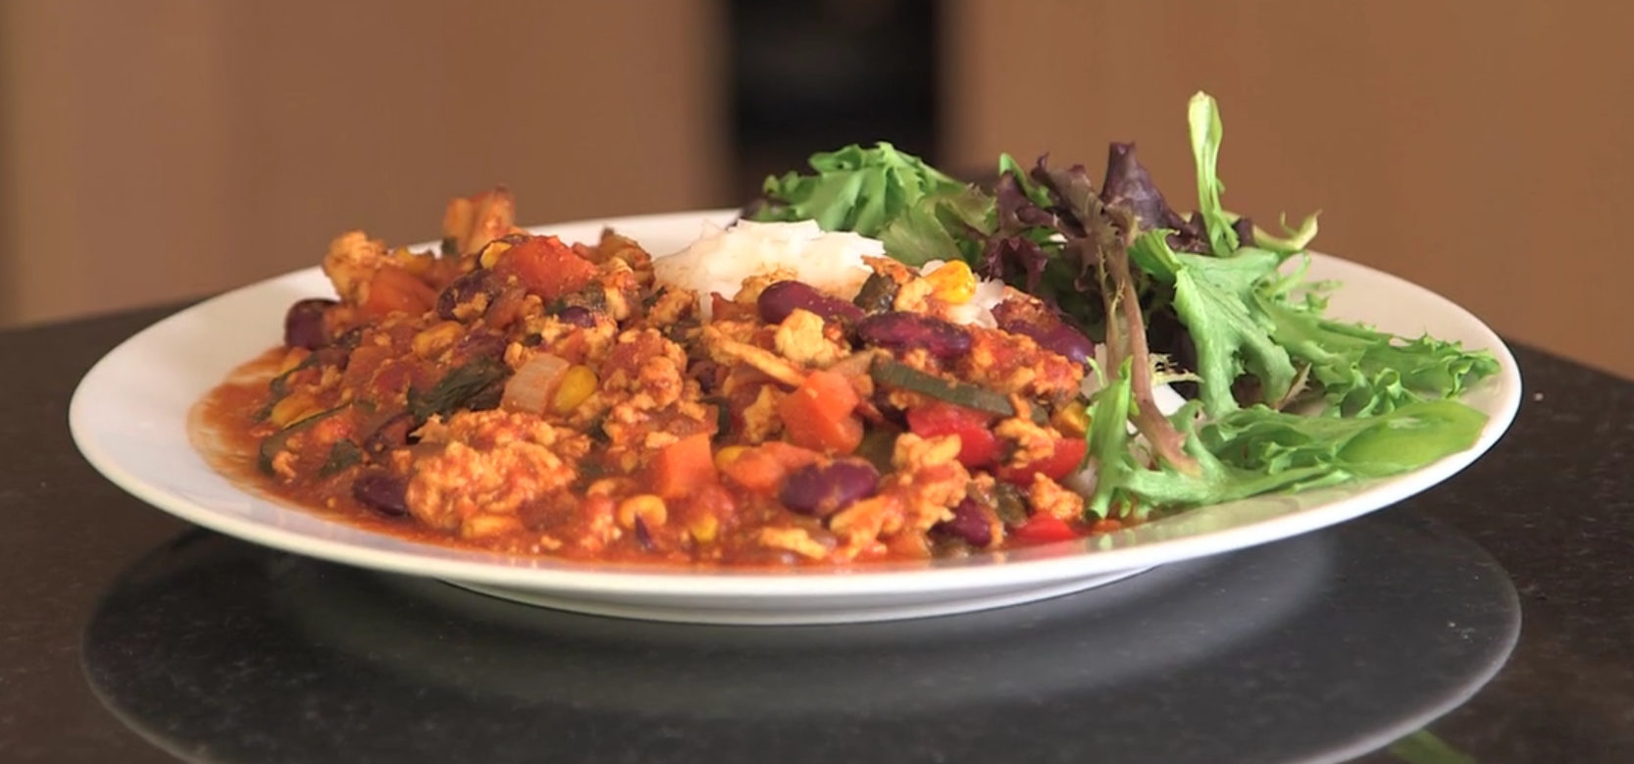

Add plenty of fresh veggies to make this hot and healthy filling meal.

Serves 4 (based on Change 4 Life recipe)

You will need:

300g extra lean minced beef
1 large onion - finely chopped
2 garlic cloves - finely chopped
Tin of chopped tomatoes
2 teaspoons tomato puree
2 teaspoons chilli powder
1 teaspoon ground cumin
1 red pepper (deseeded and chopped)
2 handfuls mushrooms (sliced)
Tin of red kidney beans in water (drained)
150ml reduced salt vegetable or chicken stock
300g easy cook white or brown rice
1 pinch ground black pepper

What to do:
- Heat a large saucepan with a little oil and add the minced beef, a handful at a time, cooking it until browned. Add the onion and garlic and cook for another 2-3 minutes.
- Add the chopped tomatoes, tomato puree, spices, red pepper, mushrooms, kidney beans and stock.
- Bring to the boil, then lower the heat and simmer gently for between 15-20 minutes.
- Meanwhile, cook the rice according to pack instructions.
- Serve with boiled rice

Try with a dollop of low fat natural yogurt on top!

Jacket potato with beans and salad

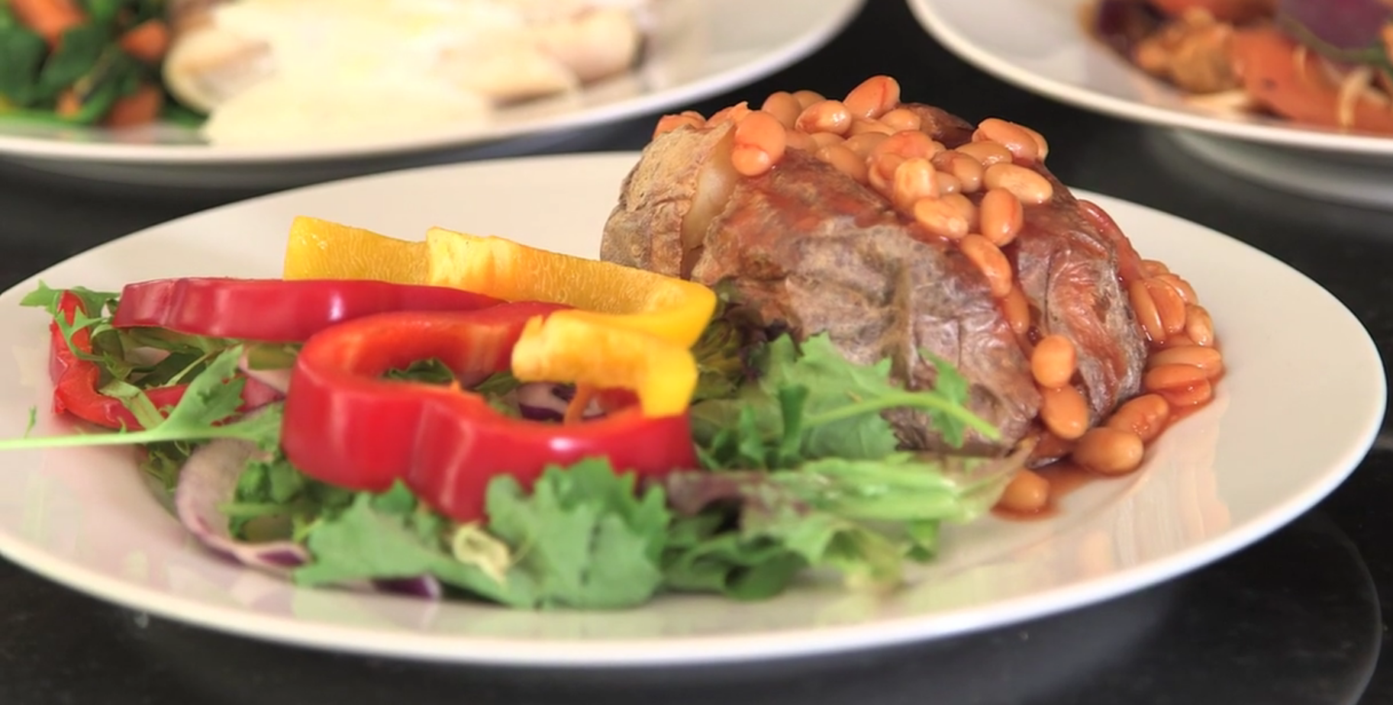

A really cheap, easy and filling meal! Add a small amount of grated cheese for extra flavour.

You will need:

Baking potato – one per person
Small tin of baked beans
Lettuce or salad leaves
Cucumber
Tomatoes
Peppers
Low calorie salad dressing

What to do:

- Preheat the oven to 200°C/fan oven 180°C/gas mark 6. Prick the potatoes, then bake in the top of the oven for 1 hour, or until crisp on the outside and soft inside. Alternatively you can microwave them on full power for 5-6 minutes but you won’t get a crispy skin!
- Open the beans and heat in a microwave or saucepan.
- Prepare the salad. Wash and chop the leaves and chop the cucumber and tomatoes.
- Split the baked potatoes open and fill them with the baked beans. Serve at once with the salad on the side.

Fish with white sauce, potatoes and veg (serves 4)

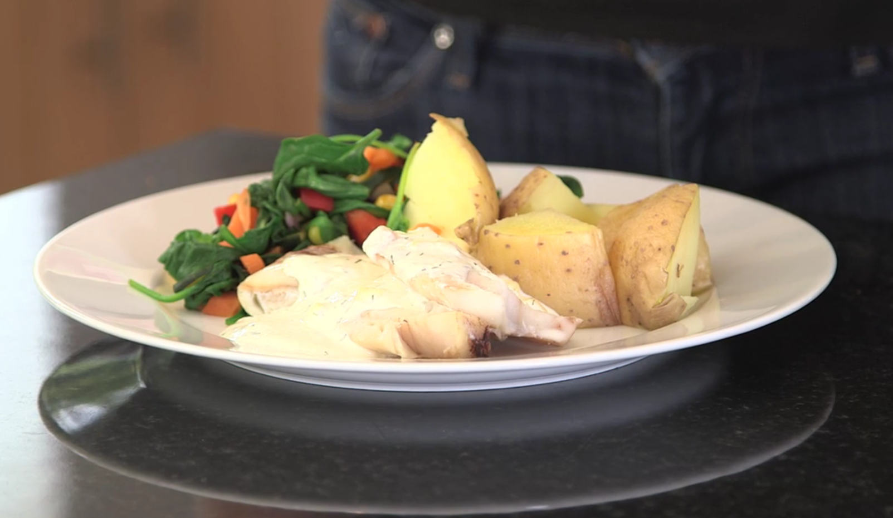

Fish is a great source of protein and essential minerals.

You will need:
Four frozen white fish fillets (or any kind of white fish or salmon)
Slices of lemon
100ml milk
Four tablespoons of low fat soft cheese
1 tablespoon of cornflour
1 teaspoon dried chives
Pinch of black pepper
400g frozen mixed veg
12 new potatoes

What to do:

- Turn on the oven to 160C.
- Place the fish in a tin foil parcel with a slice of lemon and bake for 20-25 minutes
- Cook the potatoes in boiling water for about 10 to 15 minutes (until they're soft).
- Meanwhile put a pan of water onto boil for the frozen vegetables – they only need 3-5 minutes to cook.
- Finally to make the sauce, mix the milk and flour in a small pan and warm over a medium heat then add the soft cheese and stir continuously until the sauce starts thicken and to bubble.

Pasta with mackerel and tomato

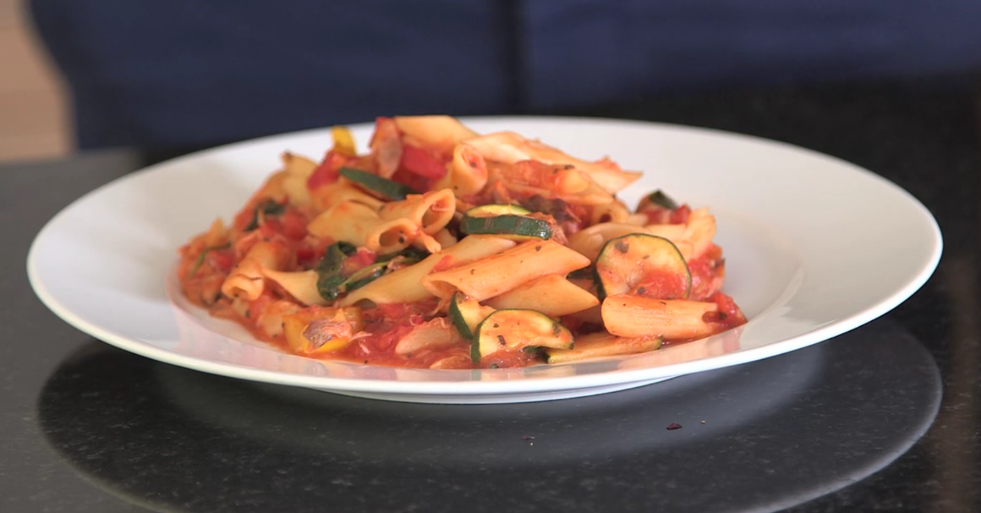

A really cheap and easy way to eat oily fish

You will need:
200g uncooked pasta (preferably wholewheat)
Vegetables such as courgettes, peppers or mushrooms (your choice!)
A packet of smoked mackerel fillets
1 teaspoon oil
1 onion, finely chopped
1 garlic clove, finely chopped
1 tin of chopped tomatoes
2 tablespoon tomato purée
a pinch of mixed dried herbs
pepper to taste

What to do:
- Prepare vegetables by chopping into small pieces. Then crush or finely chop one garlic glove
- Heat the oil in a saucepan or frying pan. Cook the onion on a medium heat until it's soft.
- Add the garlic and cook for another minute. Make sure the pan is not too hot when you add the garlic, as it burns easily. Burnt garlic will make the sauce taste bitter.
- Then add the vegetables and fry for 5 minutes
- Add the tin of chopped tomatoes, tomato purée and mixed herbs.
- Simmer gently for 15 minutes until the sauce is thick and rich.
- Break the mackerel into small pieces and add to the sauce. Heat through for a couple of minutes.
- Add pepper to taste.
- Cook the pasta in boiling water for 10-12 minutes
- Drain the pasta, then add to the sauce.

