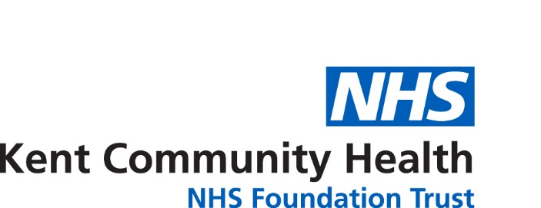
Referral form for Domiciliary Dental Treatment
NHS Dental Services
Capital House, Jubilee Way, Faversham, Kent ME13 8GD
Tel: 0300 790 0158
E-mail: kcht.communitydentalservice@nhs.net

Please print all information clearly

Eligibility Criteria for Domiciliary Oral Healthcare

Section 1

Does the patient attend his/her Doctor? YES NO
If the patient has a hospital appointment, how does he/she get there?
Ambulance Taxi Car

Other

Does the patient have someone to YES NO
bring them to the surgery?

Does the patient use a taxi for other YES NO
activities?

Please complete all sections and ensure that documents are signed to avoid delaying the referral process.

If you require assistance completing any question(s) on this form please contact the Patient Care Co-ordinator on 0300 790 0158 who will be happy to assist.

Mobility
Walks unaided Needs assistance

Wheelchair user Confined to home

Patient’s Details
Title: Gender: M F

First Name: NHS Number:

Surname: Date of Birth: Age:

Address: Telephone -

Post Code: E-mail:

Does the patient / family / carer require
an interpreter including BSL? YES NO Does the patient suffer from Dementia

Which Language: YES NO
YES
Is there any history of violence or aggression from
this patient which we should be aware of Please include details of social services or care
YES NO agency contact involved with this patient.
Are there any special access requirements or
reasonable adjustments required to support this patient Any special requirement relating to accessing
Information? E.g. Big Print, Easy Read, Audio.
If Yes please state:

If the patient has a Risk Assessment or Behaviour
Support plan in place, please attach to referral

DD / MM / YYYY
YY/MM
Home
Mobile
Alternative Contact
Section 2

YY / MM
DD / MM / YYYY

Does the patient hold an exemption certificate? YES NO
If yes, please state which exemption is applicable (For guidance please see ‘Who is entitled to help with NHS dental Charges?’ section at end of form)

Expiry Date: DD / MM / YYYY Has a Medical History Form been completed and enclosed? YES NO

Accompanying Documentation
Section 3

Treatment Required and Reason for Referral
Section 4

If referring for treatment relating to dentures please state whether or not YES NO
the patient has any natural teeth.

Name

Address

Post Code

Tel No Home Mobile

Next of Kin
Section 5

Date: DD / MM / YYYY

Full Name:

Address:

Post Code:

Telephone

Fax:

Referrer’s Details
I am the patient/ relative
(Please move to section 7)

Healthcare Professional

Residential/Care Home
Section 6

Section 7

Signature:
Date: DD / MM / YYYY

Print Name:

Please return this form to us either via post at:
NHS Dental Services, Capital House, Jubilee Way, Faversham, Kent ME13 8GD
or by e-mailing it to kcht.communitydentalservice@nhs.net
V4 July 2016

Who is entitled to help with NHS dental charges?

You can get free NHS dental treatment if you:-
- Are under 18 years old
- Are aged 18 and in full-time education
- Are pregnant or have had a baby in the previous 12 months
- Or your partner is getting Income Support
- Or your partner is getting Income-Based Jobseeker’s Allowance
- Or your partner is getting Income-Related Employment Support Allowance
- Or your partner is getting Pension Credit Guarantee Credit
- Included in an award of tax credits and meet the qualifying conditions
- Are named on a valid HC2 certificate
- Are named on a valid HC3 certificate
Only the benefits/credits listed above count for automatic help with NHS charges
The following benefits DO NOT entitle you to help with NHS dental charges:
- Incapacity Benefit
- Disability Living Allowance
- Pension Credit Savings Credit on it’s own
- Contribution-based Jobseeker’s Allowance
- Contribution – based Employment Support Allowance
- Retirement or Widows Pension
- Industrial Injuries Benefit
- Attendance Allowance
- Council Tax Benefit
- Sickness Benefit
- Mobility Allowance
- Carer’s Allowance
- Housing Benefit
If you are aged 60 or over you are entitled to free prescriptions and sight tests but not free NHS dental treatment.
If you are in full-time education you are only entitled to free NHS dental treatment if you are 18 years old.
There are no exemptions from NHS dental charges due to medical conditions. There are certain conditions that entitle you to free prescriptions and/or sight tests but not to free NHS dental treatment. If you have a NHS Medical Exemption Certificate you are entitled to free prescriptions but NOT free dental treatment.
If you have to pay NHS charges and you are on a low income you might be able to get help by applying to the NHS Low Income Scheme.

